Original score/path | File name | Image | G1 | G2 | G3 | G4
Plus-Classified\27\' | 0006D866-019F-4AAA-A29D-64B7B48B54CF | 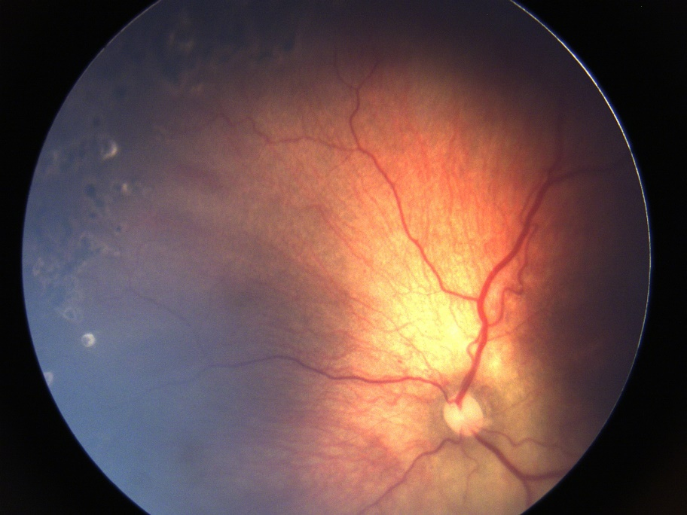 | 3 | 3 | 3 | 3
Plus-Classified\14\' | 001AF6E3-9C79-471D-9B5B-5D7E4E786FCC | 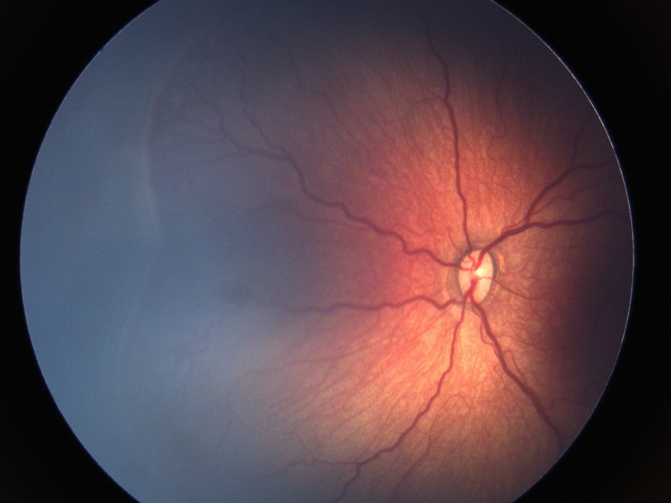 | 4 | 4 | 3 | 4
Plus-Classified\10\' | 007DB82F-3292-4FB0-B269-0749A978CD25 | 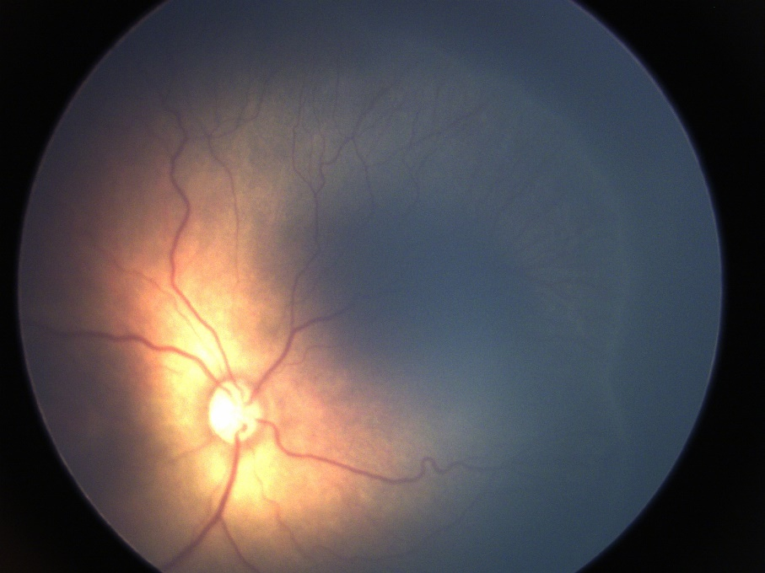 | 3 | 3 | 2 | 4
Plus-Classified\46\' | 01E174A6-FBBD-4D6C-8666-77D95131EE80 | 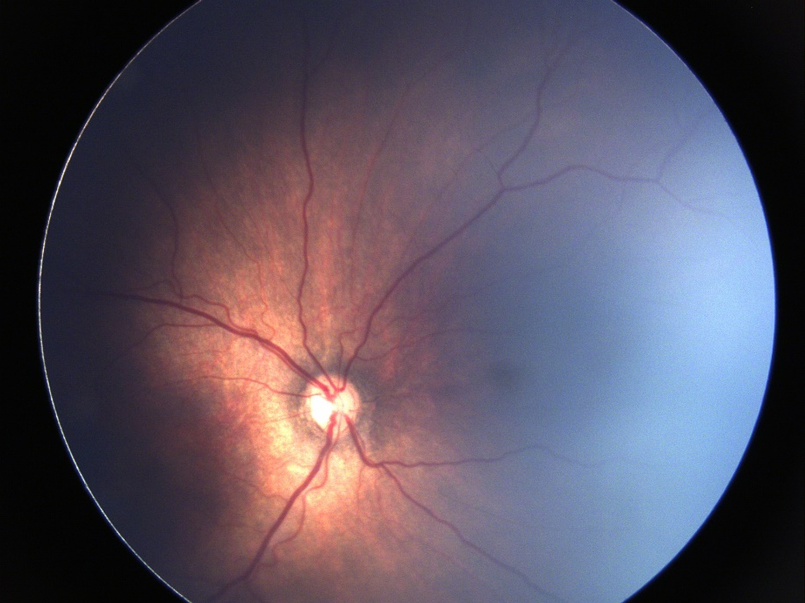 | 3 | 3 | 2 | 2
Pre-Plus Classified\54\' | 01FF8D14-0568-4445-9DB3-A54659949ED3 | 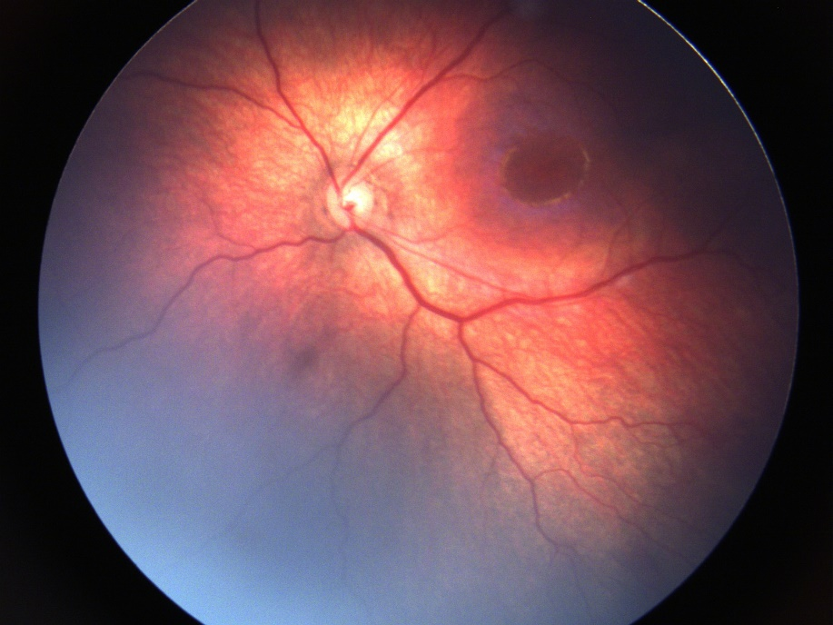 | 2 | 2 | 2 | 3
Pre-Plus Classified\23\' | 0E3DA0C6-AC10-482B-9C72-1131AFC9FAD4 | 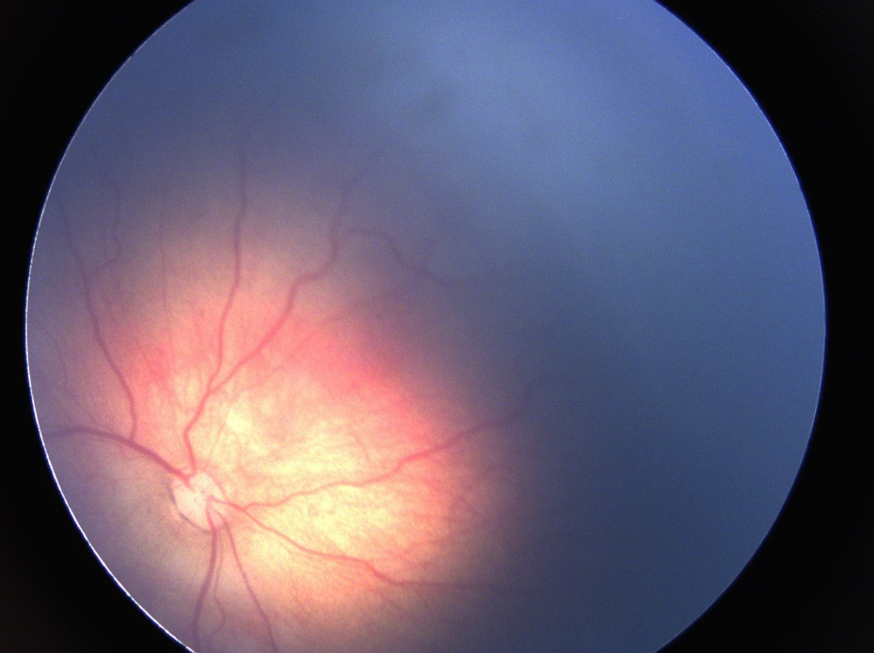 | 2 | 3 | 2 | 3
Pre-Plus Classified\19\' | 0F510E6A-9D69-42C2-AA04-6267C3BB8BBA | 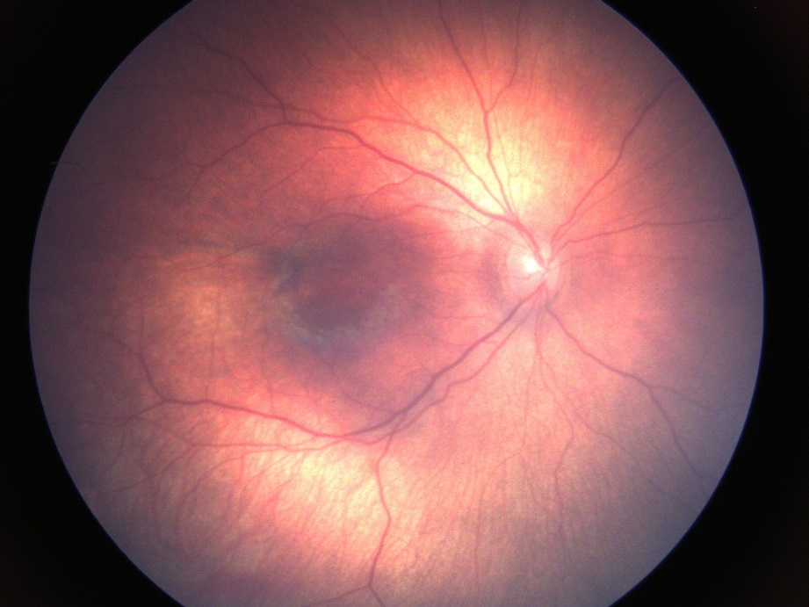 | 1 | 1 | 1 | 1
Plus-Classified\11\' | 100F0AF6-6C1E-4F66-9198-B1D93AD78CEA | 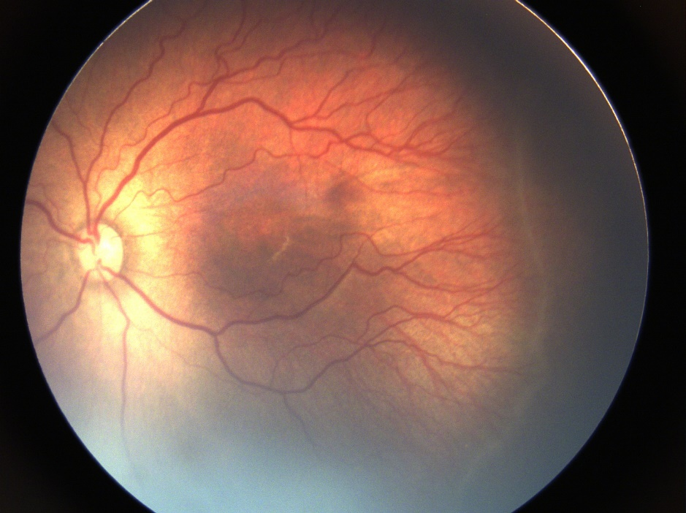 | 4 | 4 | 5 | 4
Pre-Plus Classified\25\' | 1718D367-4D17-4668-B46E-EDCABDBB2092 | 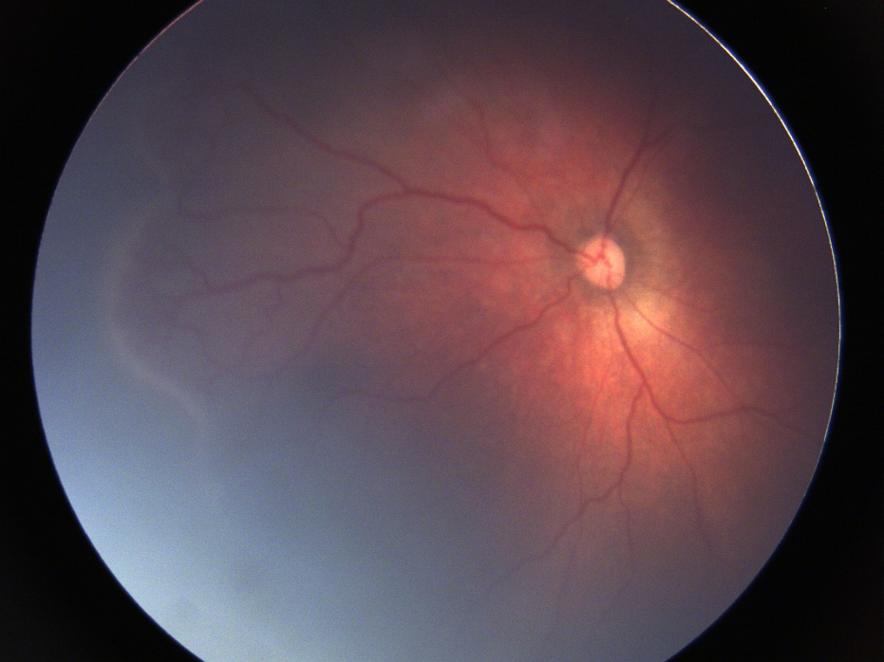 | 3 | 2 | 2 | 4
Pre-Plus Classified\58\' | 1A949A61-C4AB-4B11-A093-07E15B3C5412 | 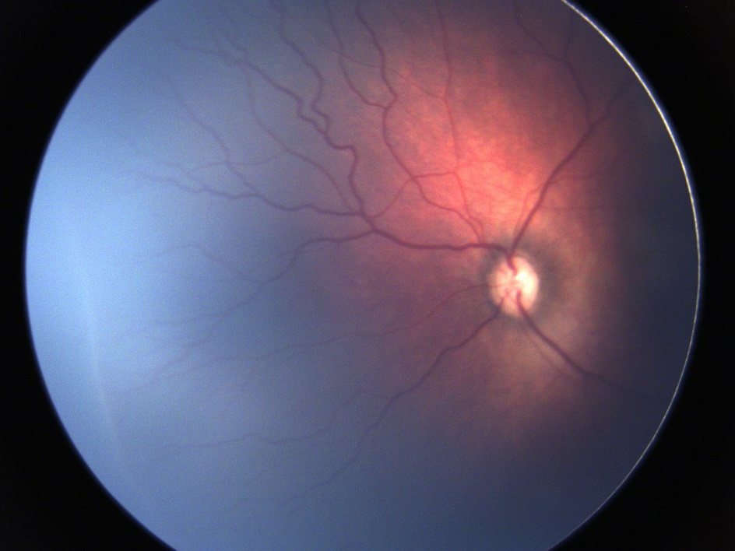 | 3 | 3 | 2 | 4
Pre-Plus Classified\104\' | 1B3E1AE2-EE93-44A9-AAAE-ABEC6A943D83 | 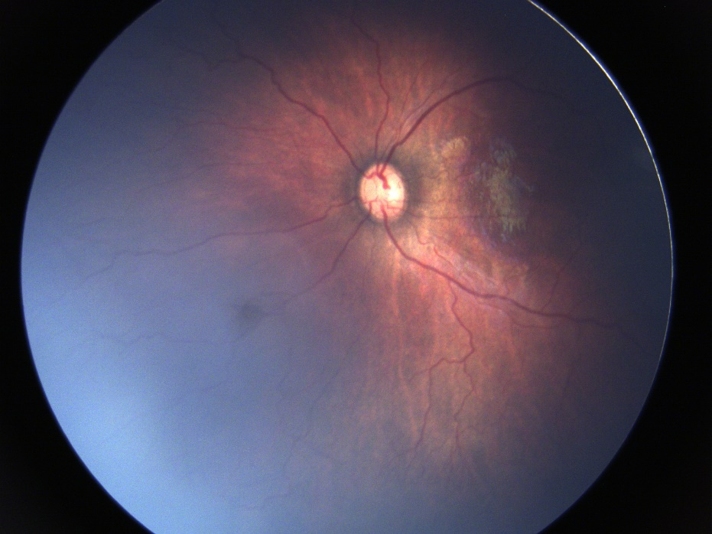 | 2 | 3 | 1 | 3
Plus-Classified\8\' | 1D386DBC-BDA8-4D9E-8D6C-EF4B194EF367 | 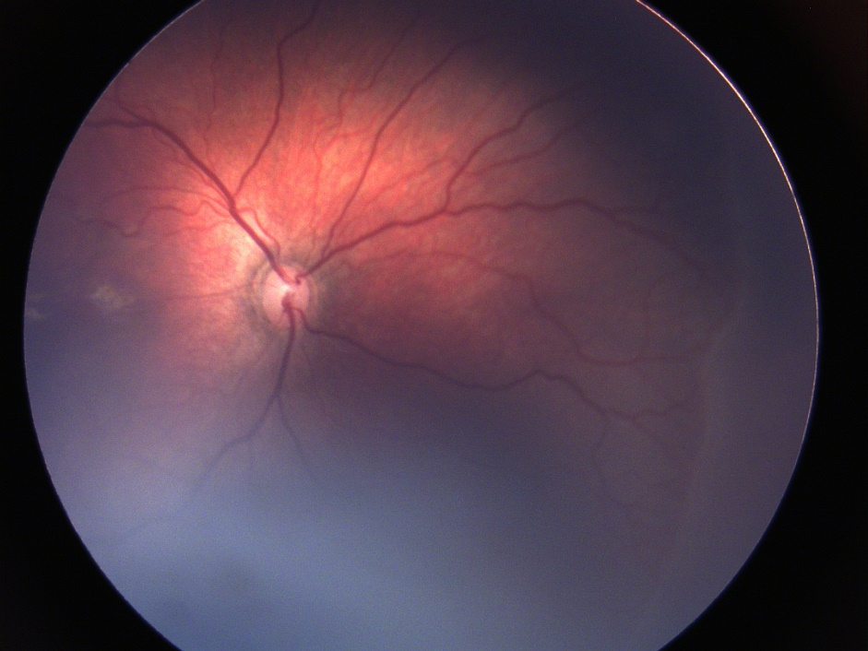 | 3 | 3 | 3 | 4
Pre-Plus Classified\20\' | 204202DD-0166-47CE-BCD2-B9E9320D1CAC | 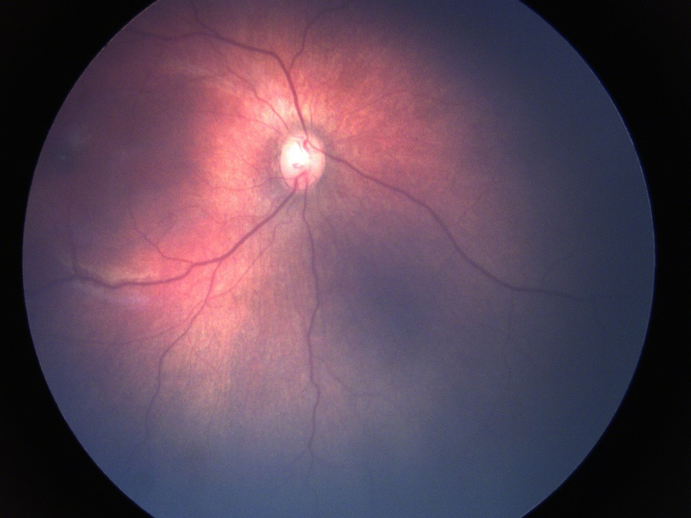 | 2 | 2 | 1 | 1
Plus-Classified\7\' | 3576DFA0-BA8F-416C-91A7-A6FDA9377C53 | 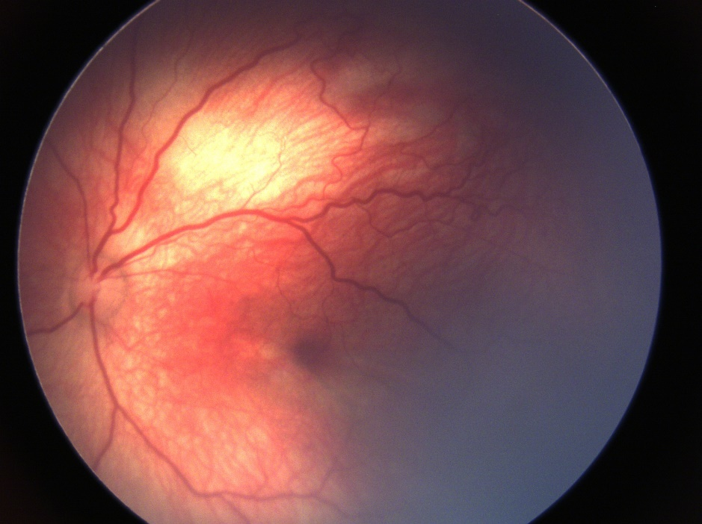 | 3 | 3 | 3 | 4
Pre-Plus Classified\96\' | 35DCCCA0-FD1D-410D-97F5-B1B2D0C830E5 | 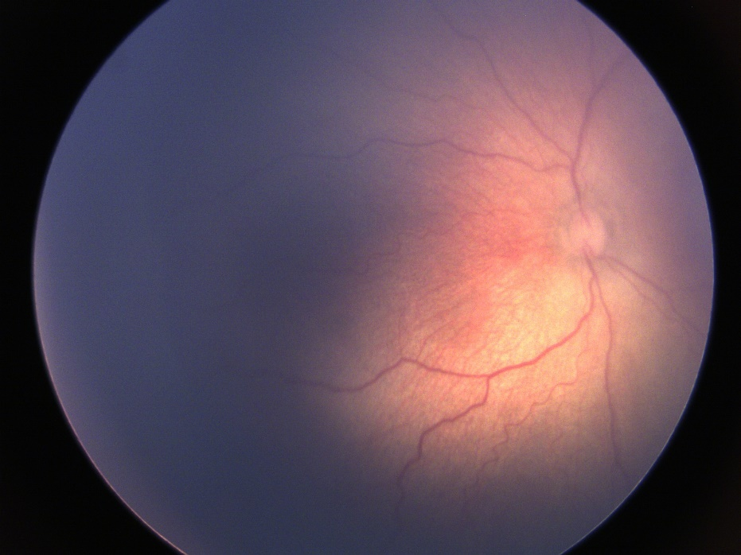 | 2 | 3 | 2 | 2
Pre-Plus Classified\24\' | 38CEDA94-0C7D-4D27-8788-089F1B2DCEE5 | 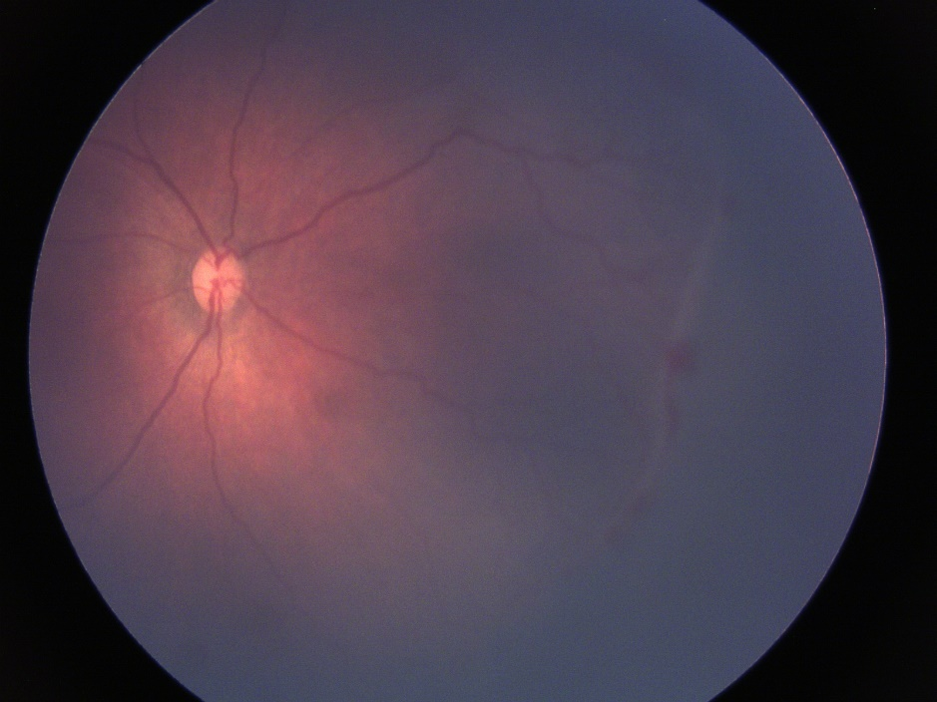 | 3 | 2 | 2 | 4
Pre-Plus Classified\107\' | 443CF866-C7EF-4984-9139-ACFFFFC806FC | 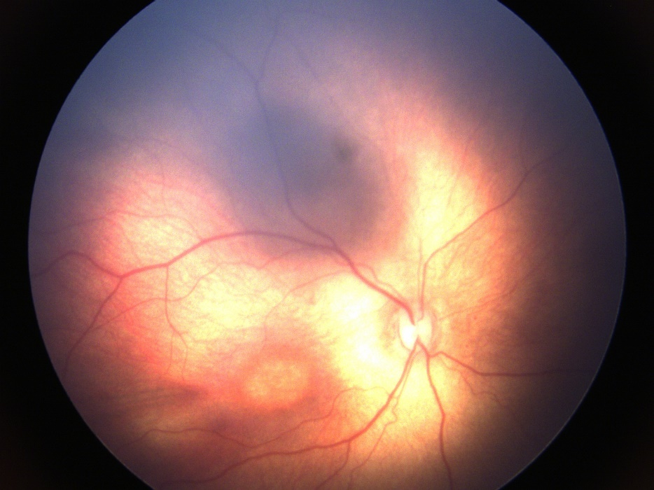 | 2 | 2 | 2 | 2
Pre-Plus Classified\82\' | 45640182-4697-472E-9BD6-D8C952FA5DBA | 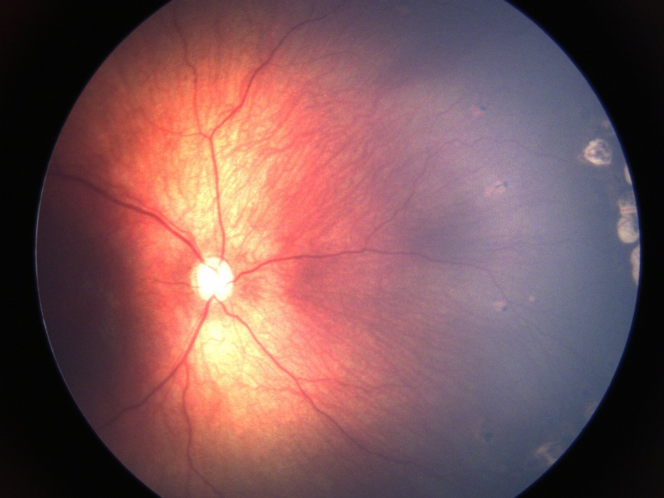 | 2 | 2 | 1 | 1
Plus-Classified\32\' | 46C9E4C4-61D9-4197-B45A-93C85685FDDE | 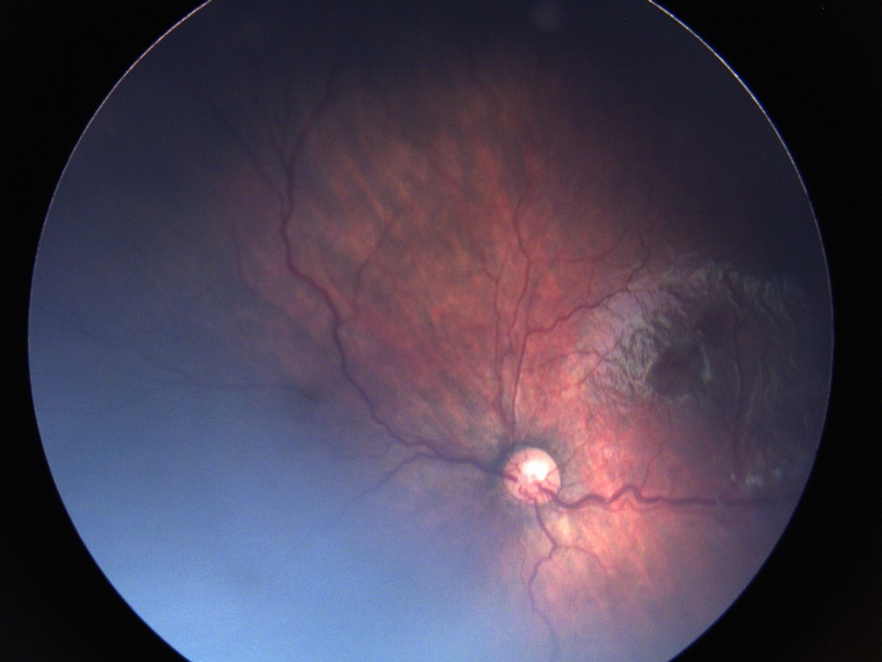 | 4 | 3 | 3 | 5
Pre-Plus Classified\86\' | 498581AF-FE1E-4F32-8AC4-3753FA72F561 | 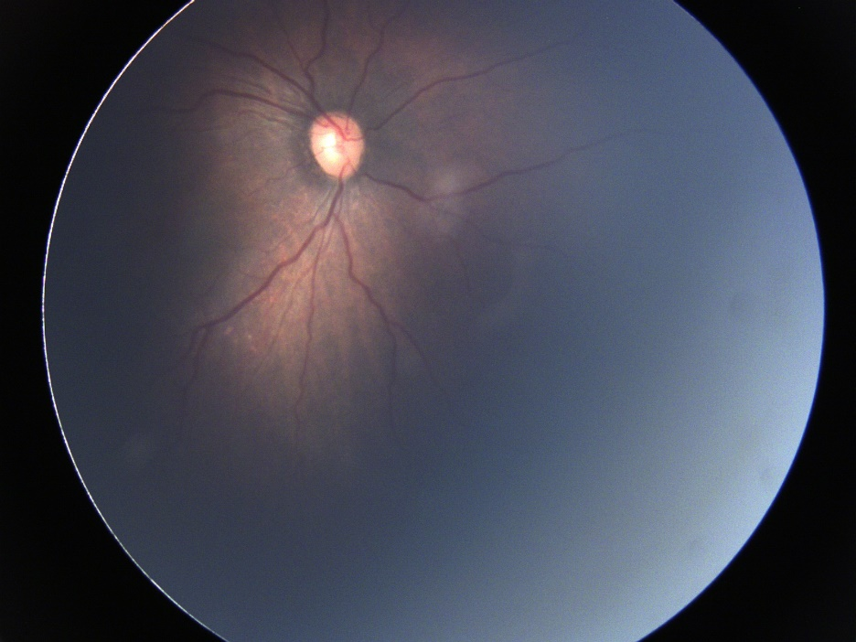 | 2 | 2 | 1 | 3
Pre-Plus Classified\42\' | 4AAE31E0-3343-4BB7-90EB-404CCFD1C143 | 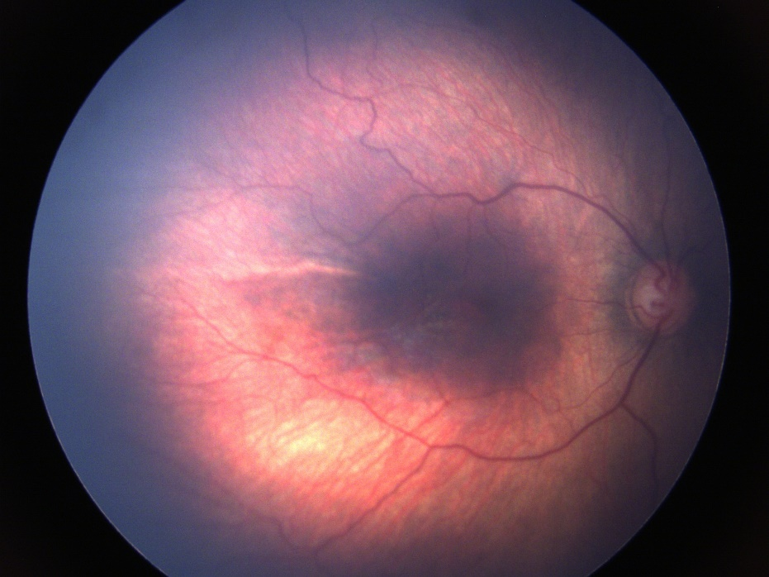 | 2 | 2 | 1 | 2
Pre-Plus Classified\62\' | 4BC33A01-D915-40A2-ABE3-D9CF9E2ACB11 | 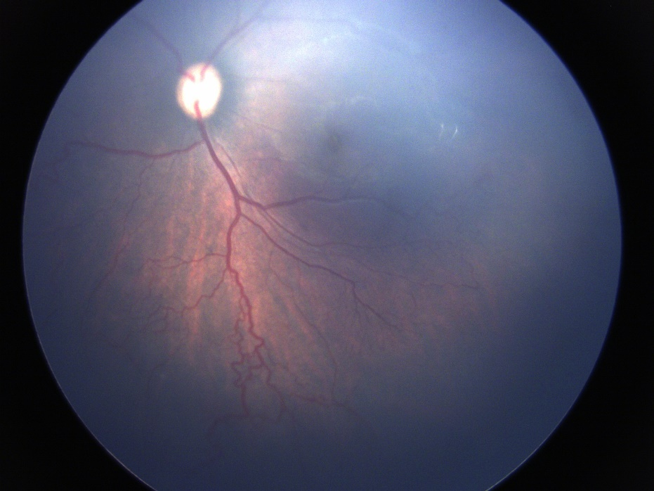 | 2 | 3 | 2 | 4
Plus-Classified\45\' | 515053D1-849B-47F3-B3D9-26D25803A1BA | 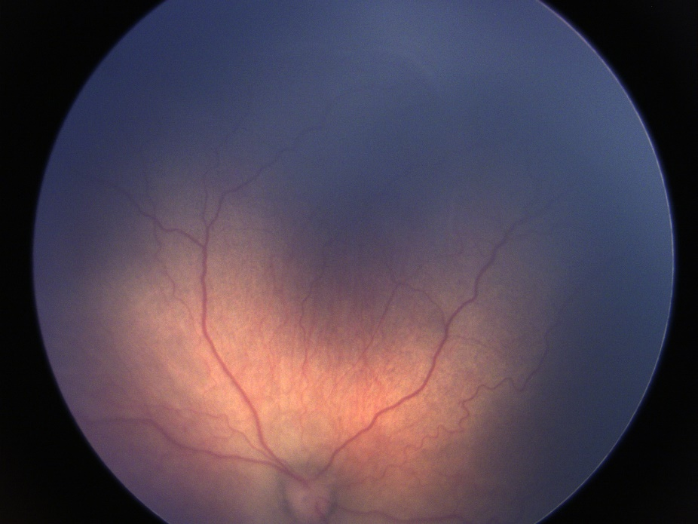 | 3 | 2 | 2 | 3
Pre-Plus Classified\65\' | 5B7D3C9A-3EA6-4A88-9625-417616814475 | 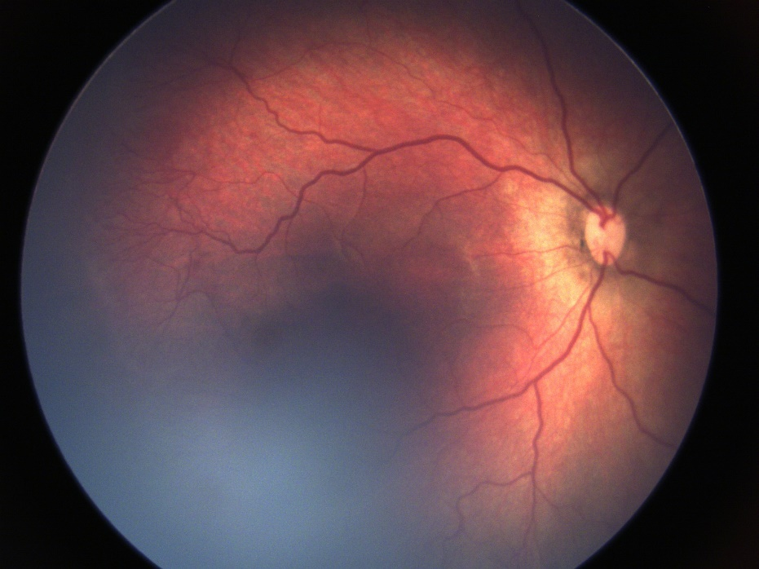 | 3 | 2 | 2 | 4
Plus-Classified\5\' | 69374A85-69C8-4FA1-9847-F33B5635C939 | 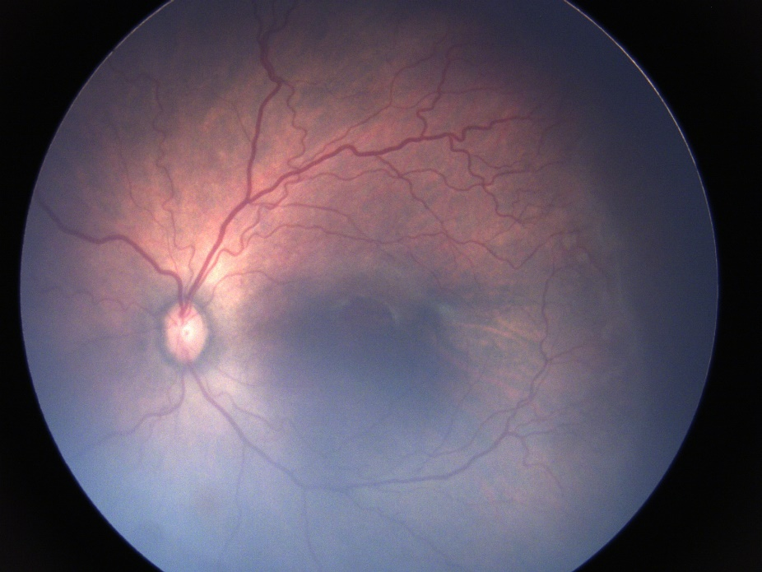 | 4 | 4 | 3 | 4
Plus-Classified\12\' | 6B4F73E4-216D-48C2-A001-E23254847608 | 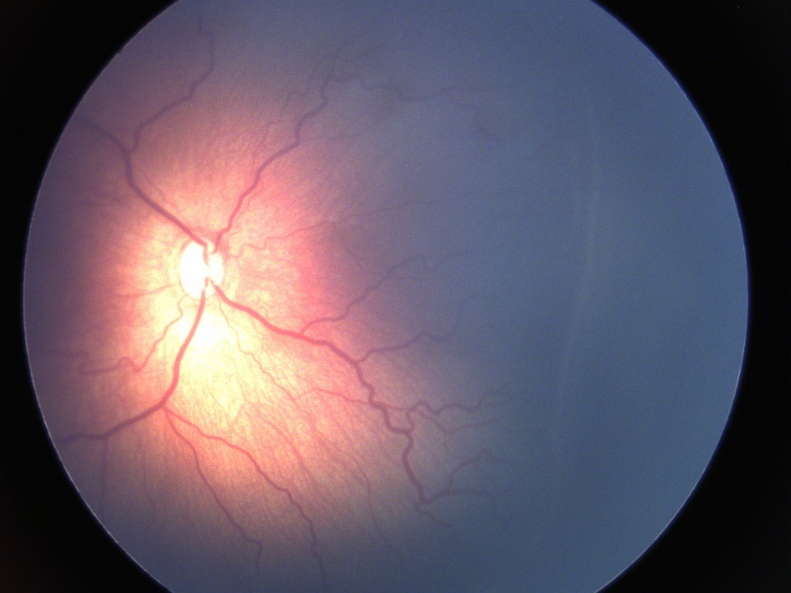 | 4 | 3 | 4 | 4
Pre-Plus Classified\51\' | 6BF9B91D-2067-46EB-870E-17F6D43BB8F6 | 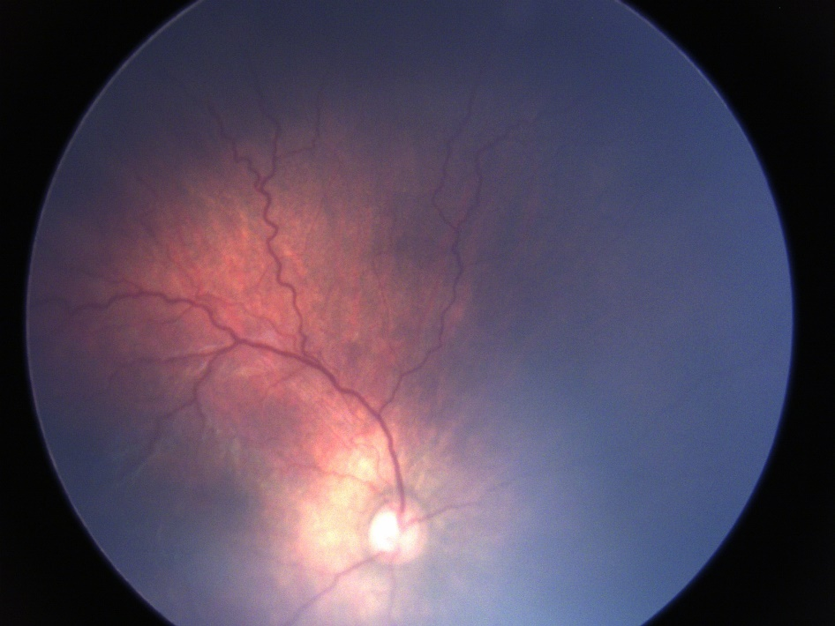 | 3 | 3 | 2 | 4
Pre-Plus Classified\11\' | 6E012357-568D-45FC-80EB-8E5D3B7AC3D5 | 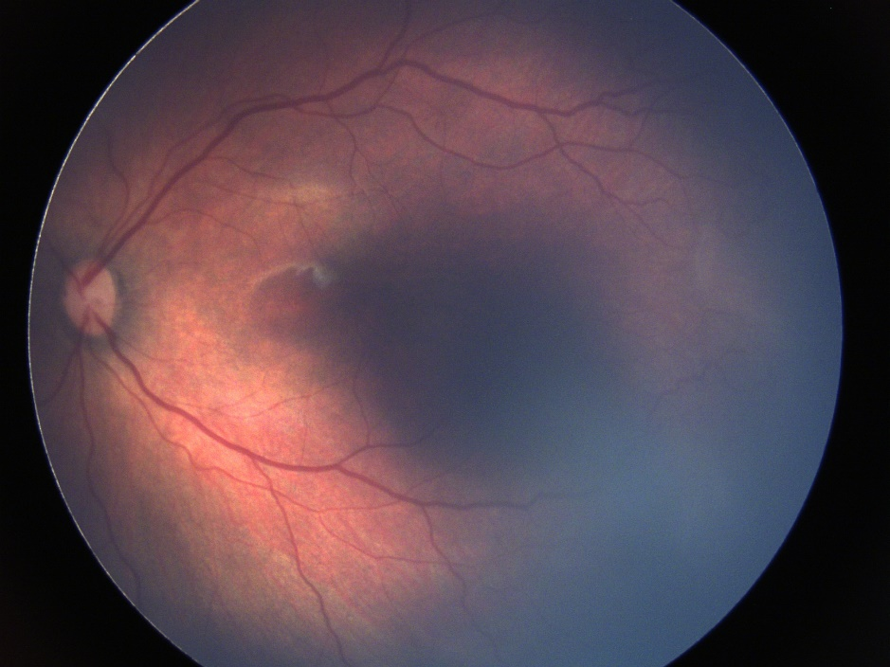 | 2 | 1 | 2 | 2
Pre-Plus Classified\27\' | 7344E3F5-D81C-4A68-99E2-D5A7590C98D7 | 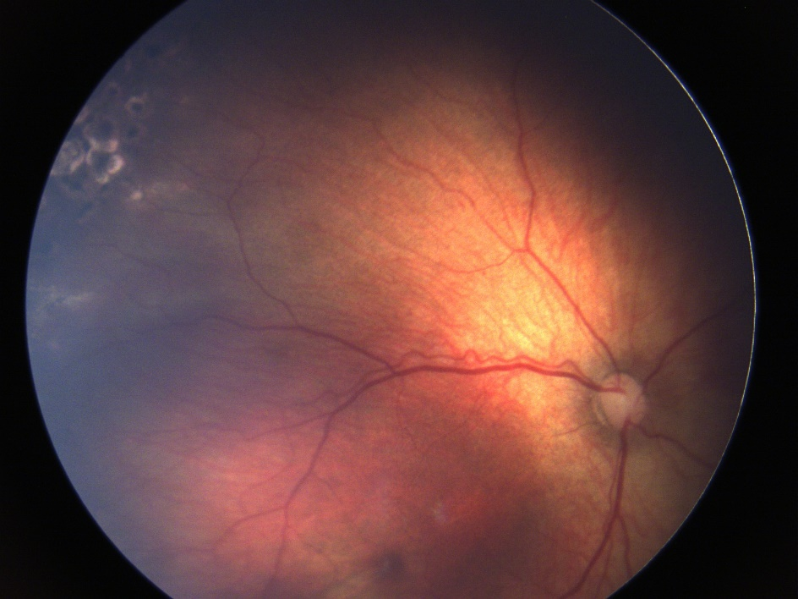 | 3 | 3 | 2 | 2
Plus-Classified\41\' | 7408FFB2-7558-493A-ADF1-42541105CF6C | 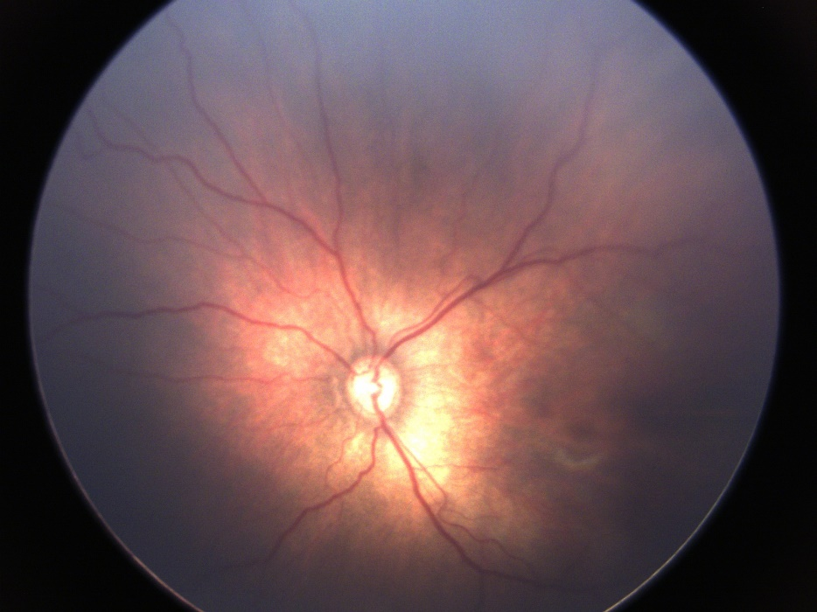 | 3 | 2 | 2 | 3
Plus-Classified\50\' | 749A75A7-555B-40F7-B749-BB345A5A67FF | 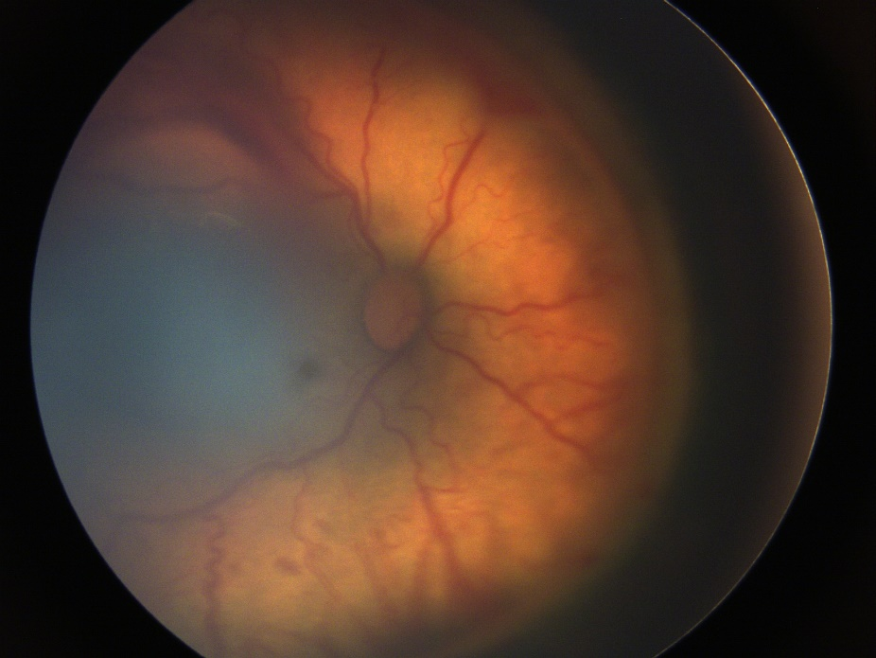 | 5 | 5 | 3 | 5
Plus-Classified\4\' | 750FB3EC-B4EE-4AD1-83D5-327A1E1A991C | 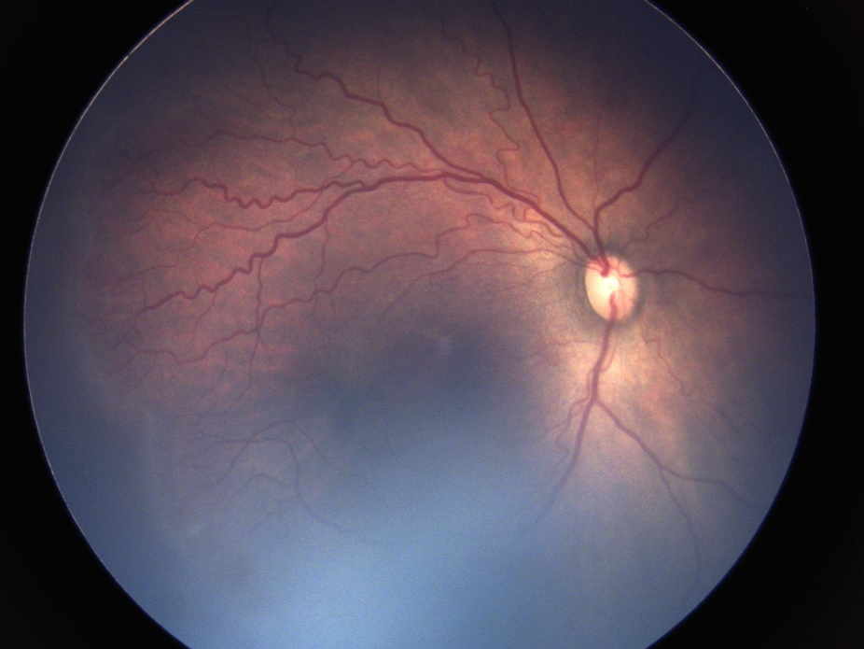 | 4 | 4 | 3 | 4
Pre-Plus Classified\67\' | 75EE7D00-FD1F-4589-B350-957BABEEBE5E | 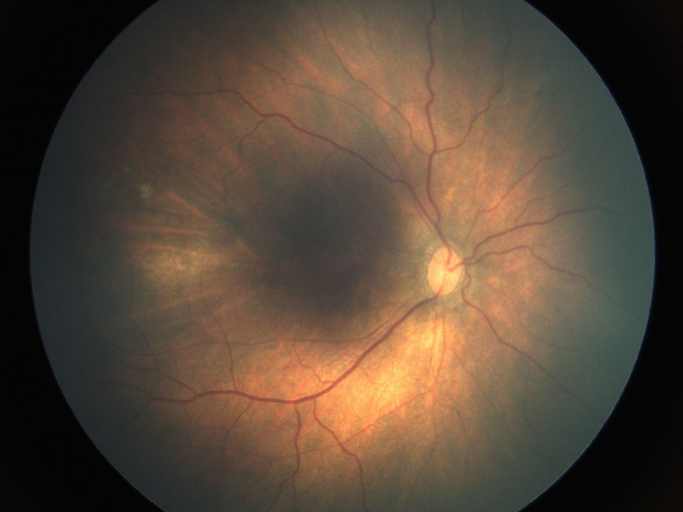 | 2 | 2 | 2 | 2
Plus-Classified\42\' | 77997EC5-E48B-44C9-A355-F8D7C9B35F1E | 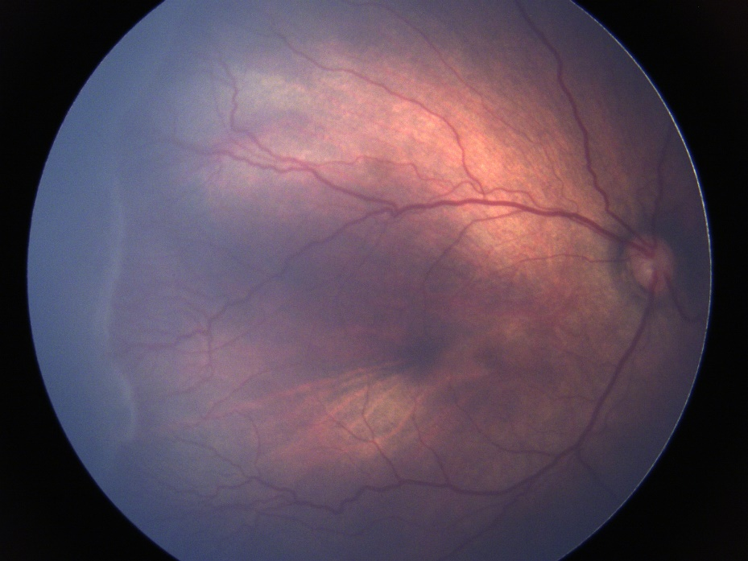 | 3 | 3 | 3 | 4
Pre-Plus Classified\57\' | 841F5A4C-A952-4CD1-BB07-E5B5692129EE | 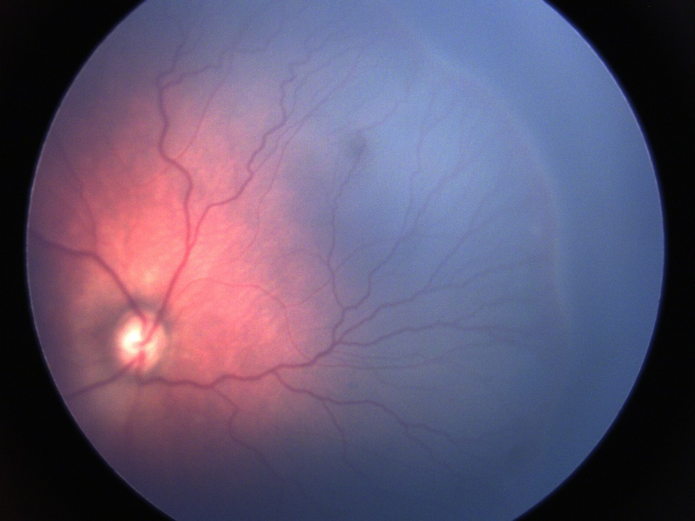 | 4 | 2 | 3 | 5
Plus-Classified\48\' | 8AA13EC8-1CEE-416D-8B99-2AD818CD433C | 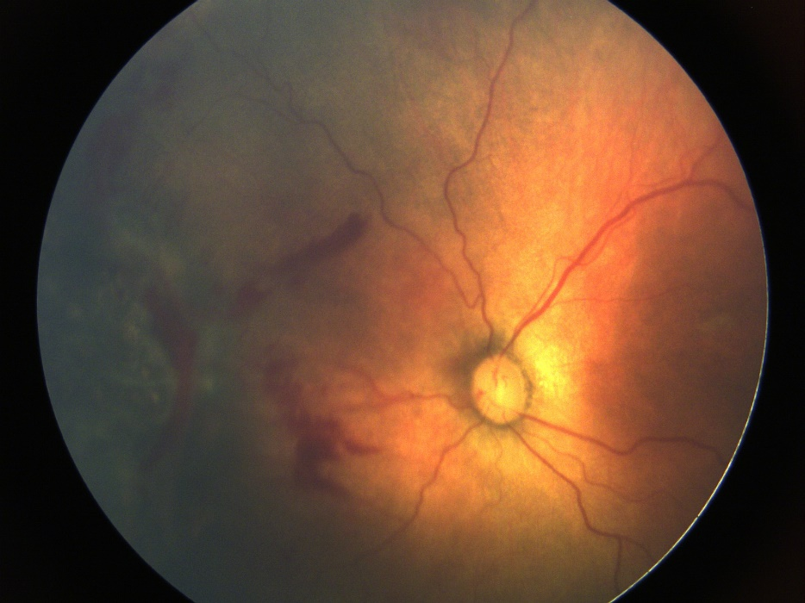 | 3 | 2 | 3 | 4
Plus-Classified\49\' | 8B26DB2E-E0D7-4CBA-844C-CDAD59AB266E | 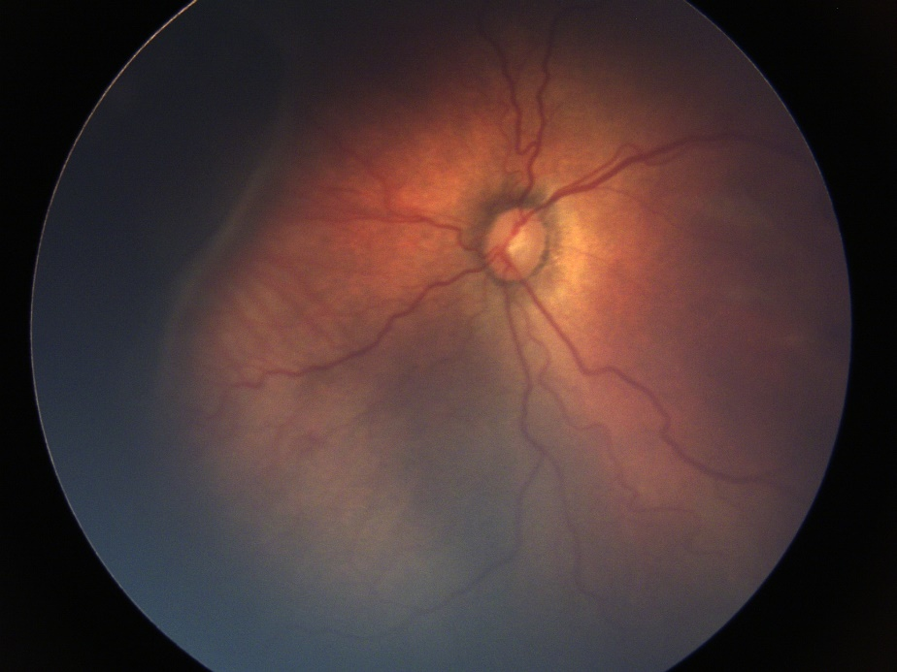 | 4 | 4 | 4 | 5
Plus-Classified\22\' | 8B733122-59AD-4AEA-904A-DBEEFF2EF484 | 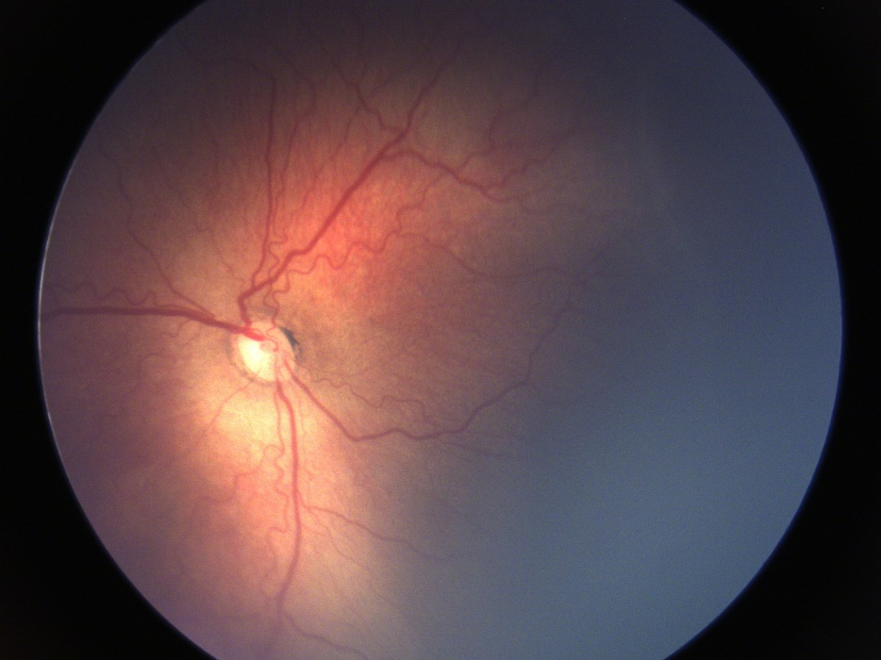 | 4 | 4 | 3 | 4
Plus-Classified\20\' | 8FEF082E-4814-4EC4-8496-3614E9401341 | 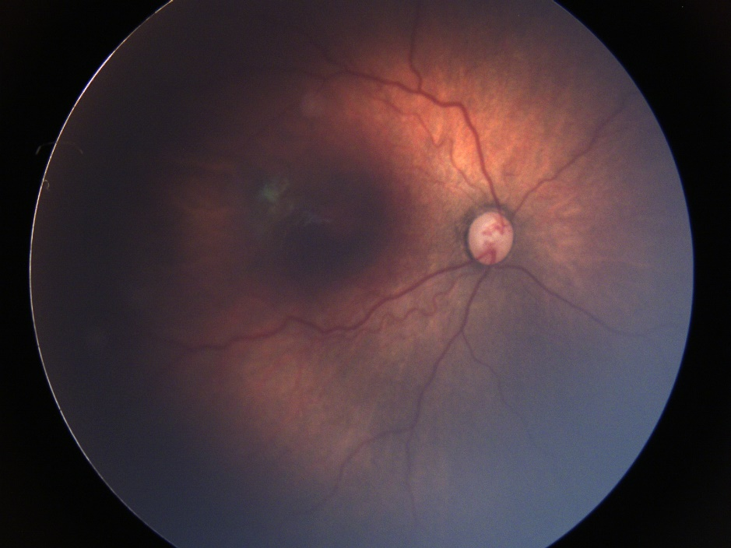 | 4 | 3 | 2 | 4
Pre-Plus Classified\111\' | 9478277A-9B30-4A71-9A31-9784BD4DDE0D | 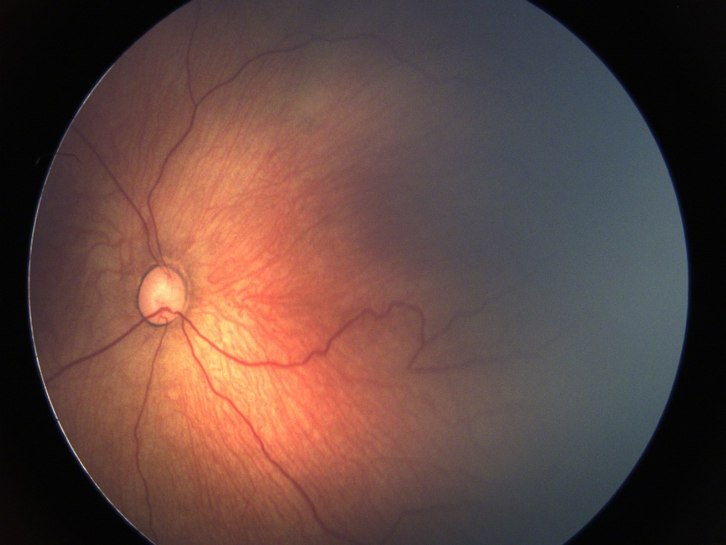 | 2 | 2 | 1 | 3
Pre-Plus Classified\21\' | 97406E0E-4D92-465E-B404-505F937AE259 | 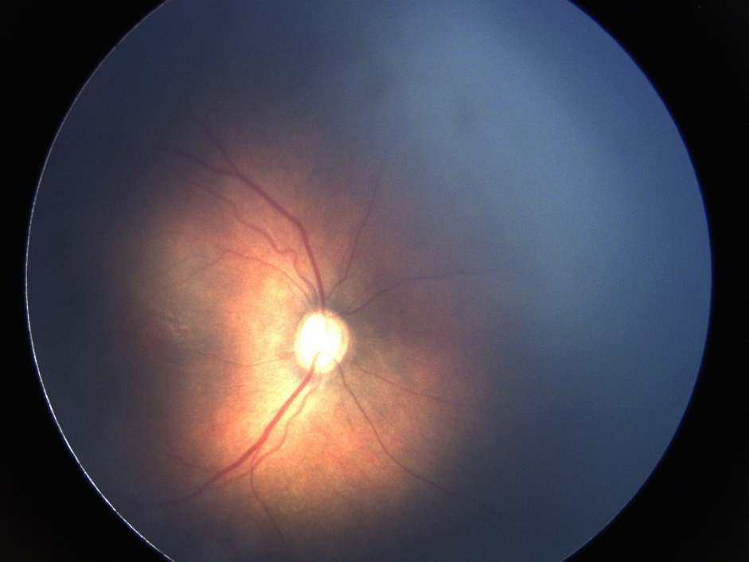 | 2 | 3 | 2 | 1
Pre-Plus Classified\48\' | 97D81CE5-3316-4723-A374-A623ED586C21 | 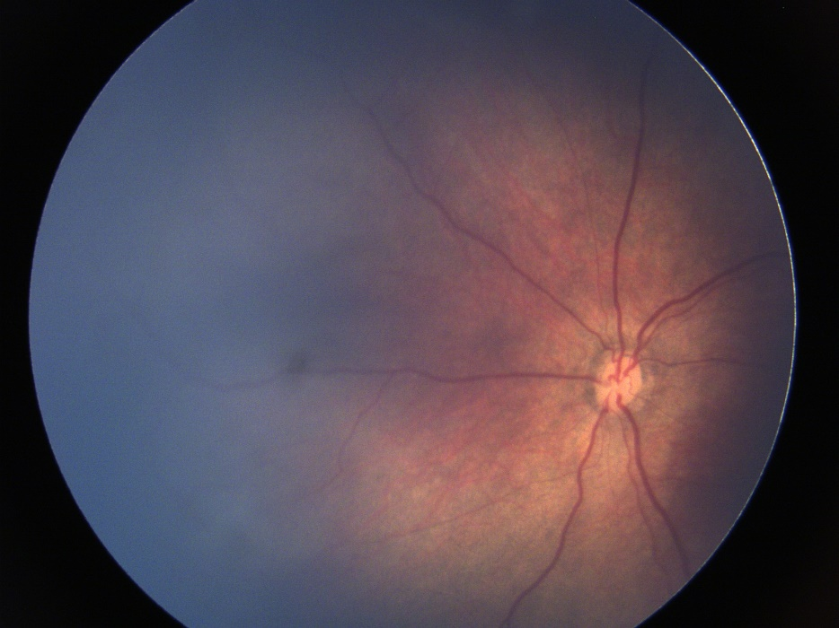 | 2 | 2 | 2 | 1
Plus-Classified\40\' | 997A4AF3-4DBA-4DA9-B85B-D050274D428B | 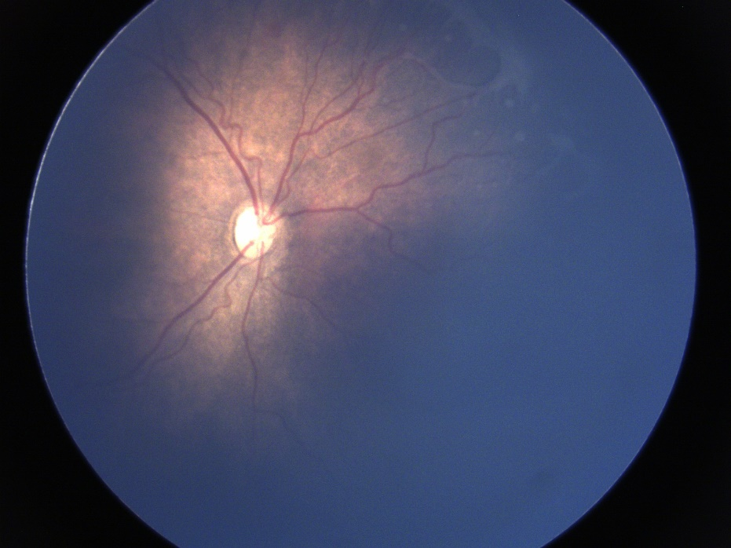 | 3 | 3 | 3 | 3
Pre-Plus Classified\41\' | 9BCE3645-1887-487B-B86F-234E7443B4C7 | 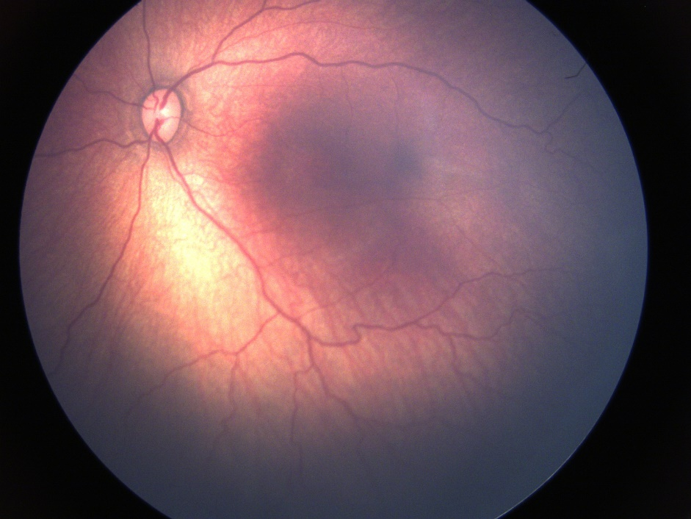 | 2 | 2 | 1 | 3
Pre-Plus Classified\101\' | A5D2BF61-6B93-46FD-9C38-E89424C5BA1F | 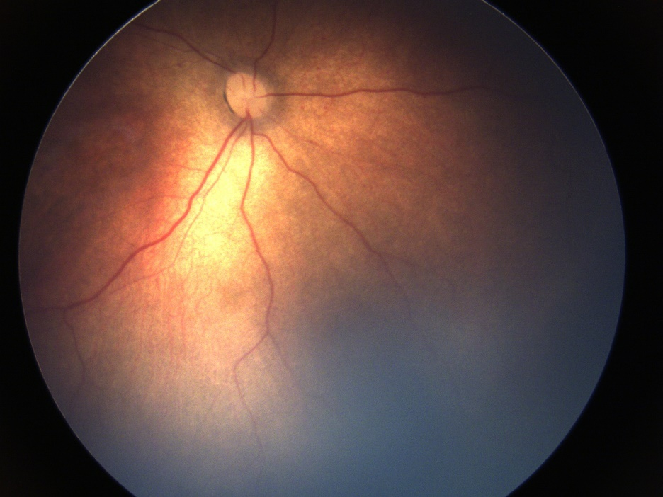 | 2 | 1 | 1 | 1
Pre-Plus Classified\78\' | A6F8DCAC-5CCA-44E4-BB64-E8AE35F8ACAA | 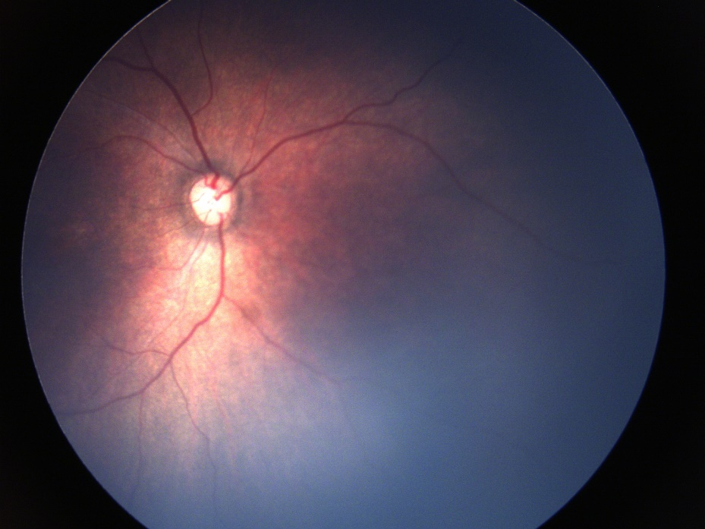 | 3 | 1 | 1 | 1
Pre-Plus Classified\47\' | AD567006-F9A8-4E94-B760-E3A190315B81 | 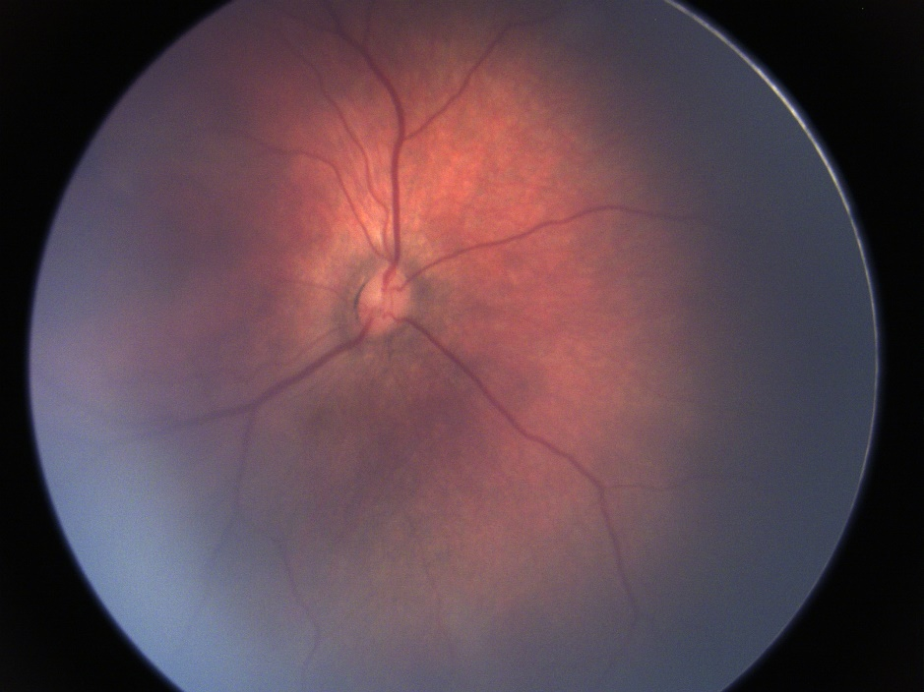 | 3 | 2 | 1 | 2
Plus-Classified\47\' | AF8DC5E4-B90F-4793-AA99-EF7588659F50 | 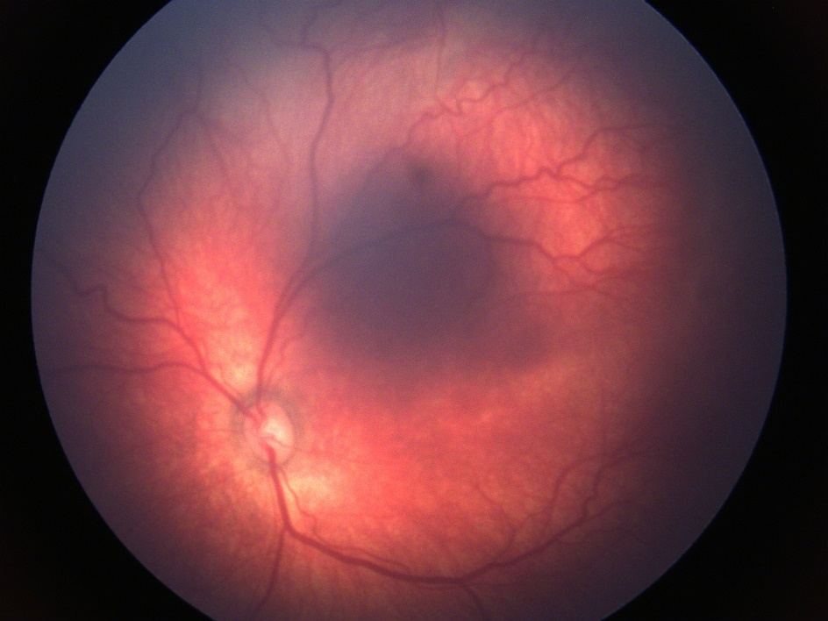 | 4 | 3 | 2 | 4
Pre-Plus Classified\74\' | AFAFDD08-D6B0-4ED1-90E8-A0F52822DC6D | 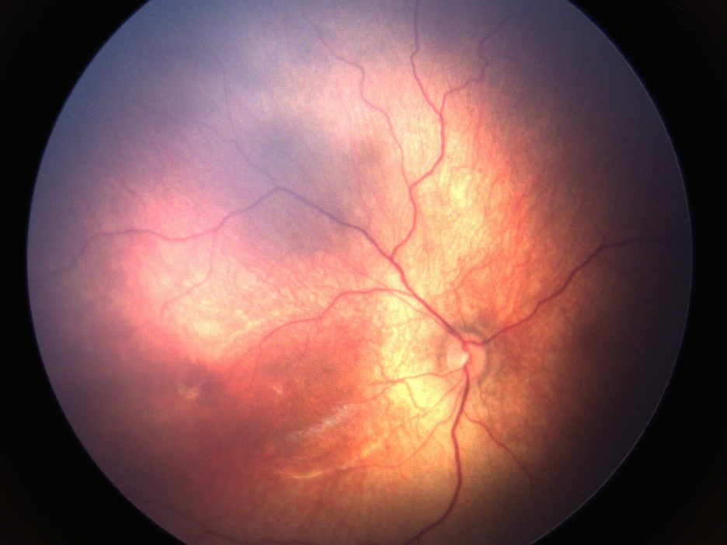 | 2 | 1 | 1 | 1
Plus-Classified\16\' | B0A4724E-76DD-49DA-B104-55B7DA237E9C | 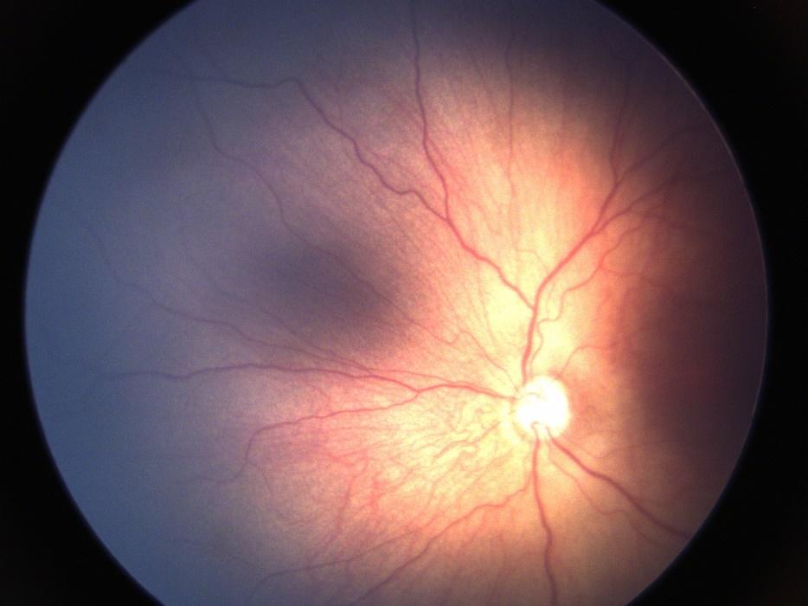 | 3 | 2 | 2 | 4
Pre-Plus Classified\71\' | B20BA90A-EE69-468D-94B2-C5078546233F | 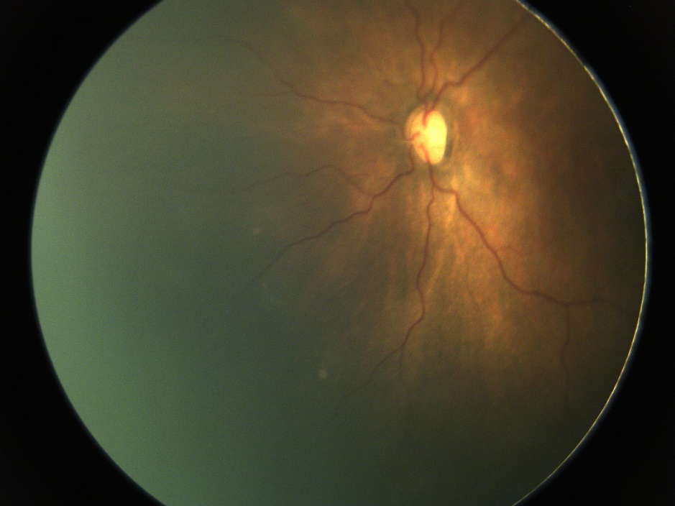 | 3 | 2 | 2 | 4
Pre-Plus Classified\32\' | B2ADA6D5-56C3-4139-95DF-B92D24FCF185 | 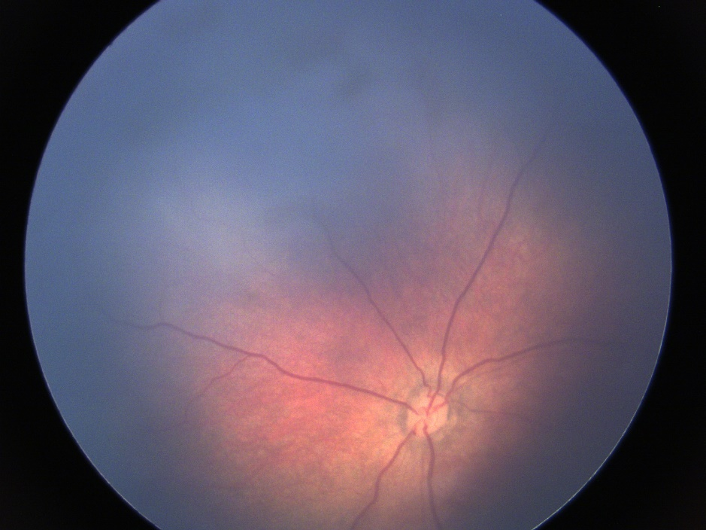 | 2 | 1 | 1 | 1
Pre-Plus Classified\5\' | B64AF243-F211-4904-AC1E-6DFED7956C3D | 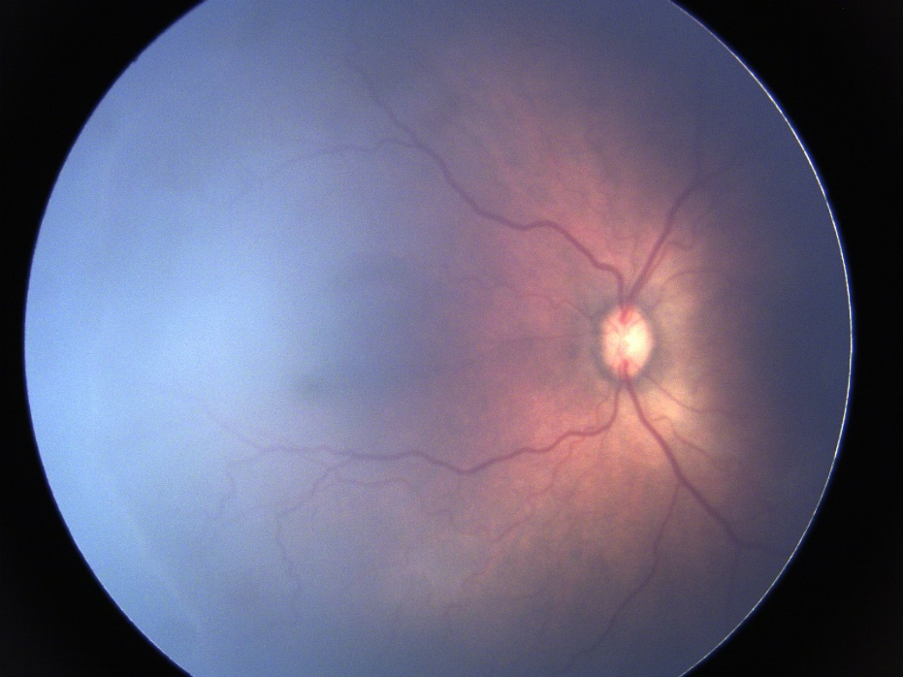 | 3 | 3 | 2 | 4
Pre-Plus Classified\16\' | C01790B6-4D44-40F7-9F14-3CB2B24FD937 | 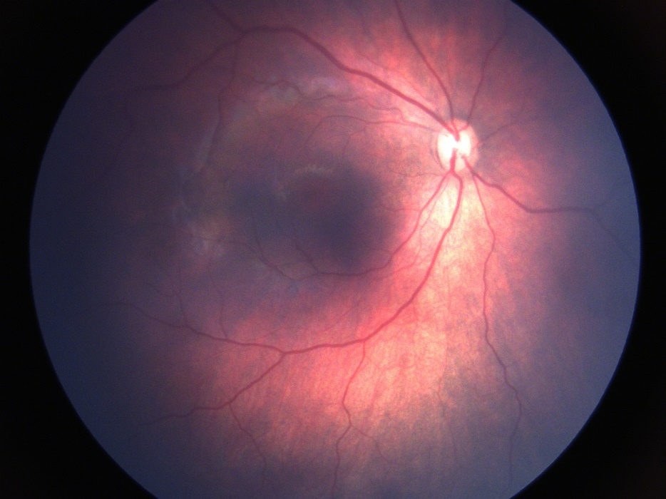 | 2 | 2 | 1 | 2
Plus-Classified\1\' | C124997C-0C05-4D99-9F1E-7FA0A0868F1B | 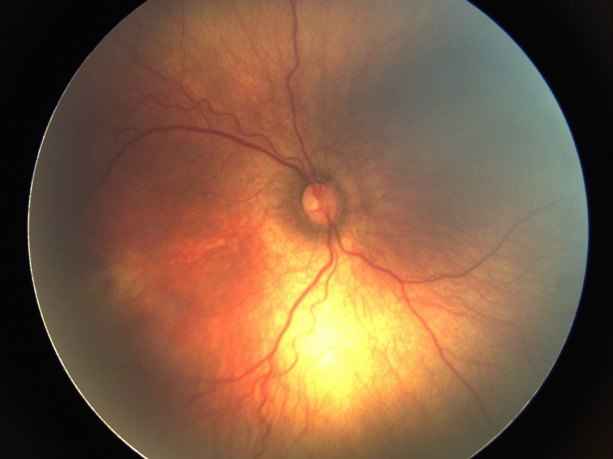 | 3 | 3 | 2 | 4
Plus-Classified\52\' | C23C860F-3CAD-4444-AD34-A04C43809A9E | 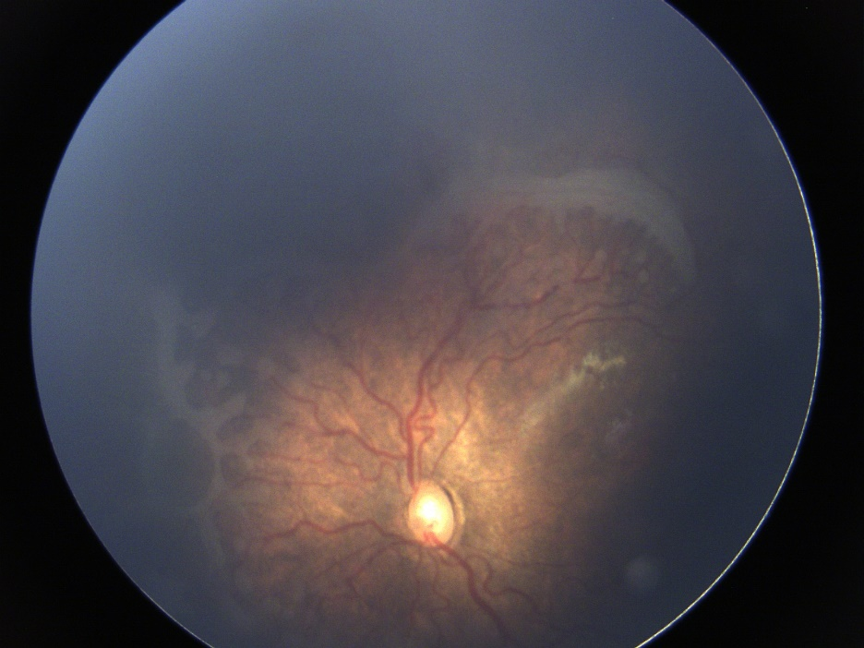 | 5 | 4 | 4 | 5
Plus-Classified\39\' | C2B33839-7B20-45AC-8265-9F281498726D | 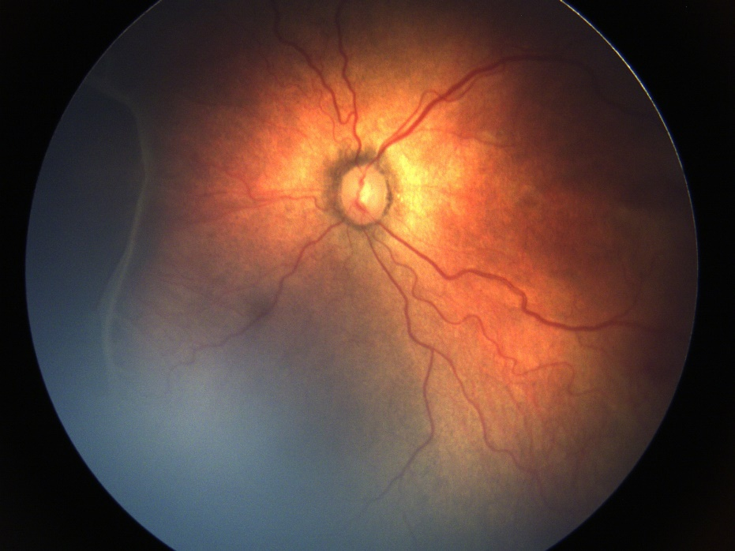 | 4 | 3 | 3 | 4
Plus-Classified\23\' | C38F68A8-33D7-4E9A-B03B-95987FE1FCA7 | 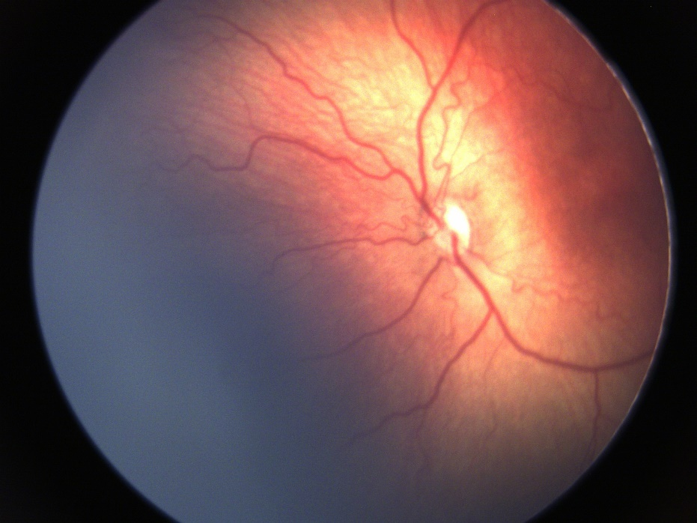 | 5 | 4 | 4 | 4
Pre-Plus Classified\93\' | C5586E72-96A9-41ED-B32A-39FCD3FEB195 | 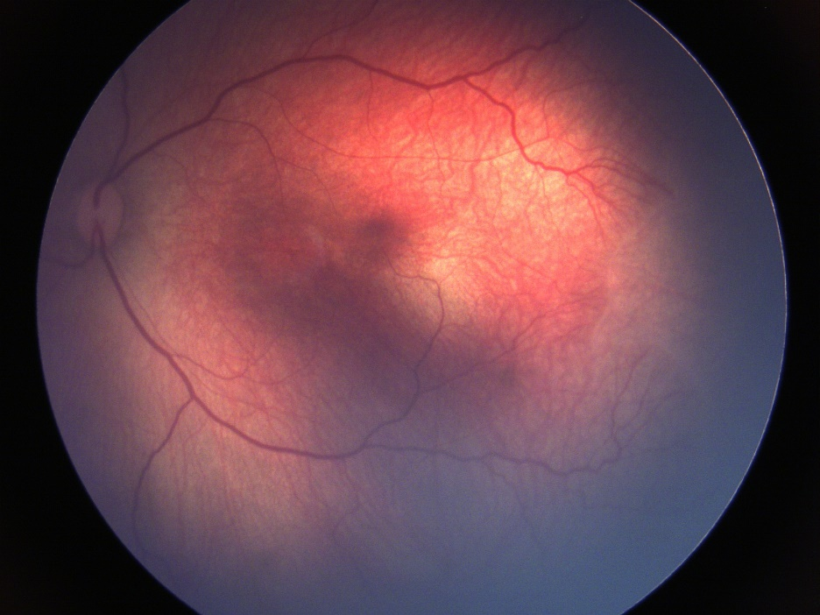 | 2 | 2 | 1 | 3
Plus-Classified\38\' | C57F7998-8706-48C2-B781-F8F0BA814DA9 | 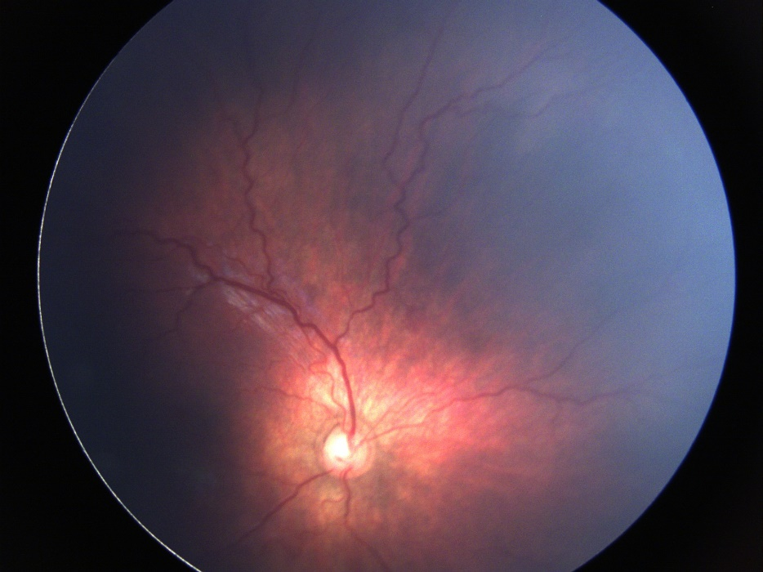 | 4 | 3 | 2 | 4
Pre-Plus Classified\36\' | C97DA7DD-9848-4E8C-A387-3C56F934EA2F | 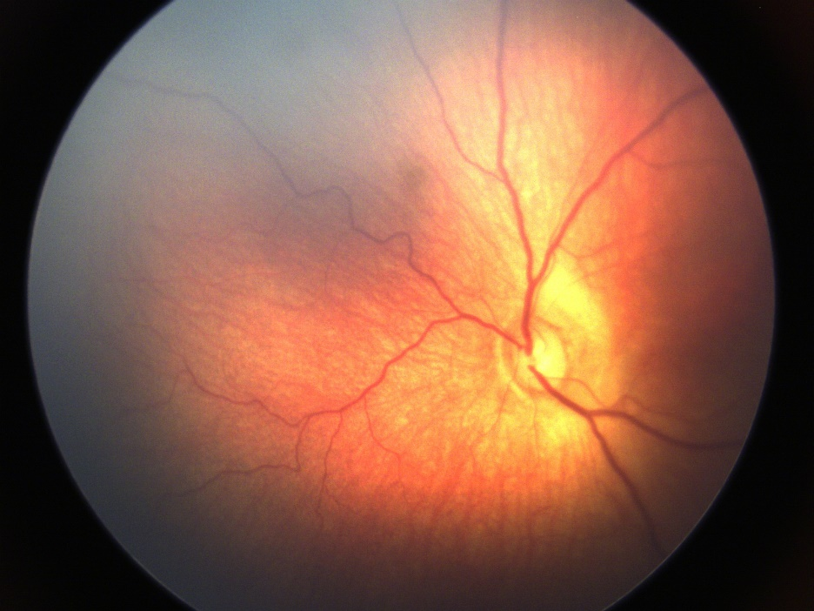 | 3 | 2 | 2 | 4
Plus-Classified\6\' | CA052AEE-C0C2-415D-83E3-0FA501A45516 | 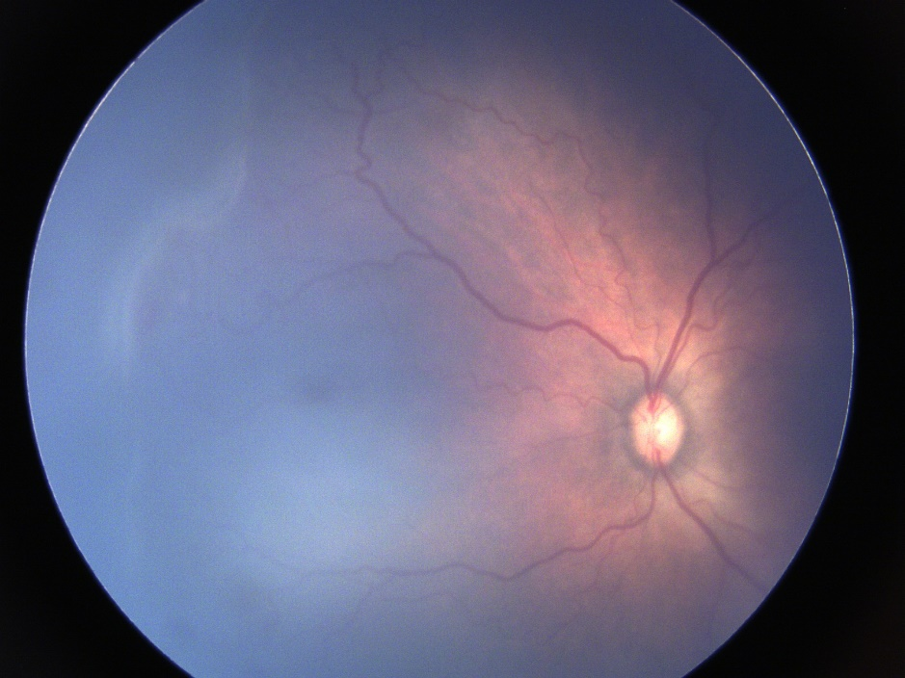 | 4 | 3 | 3 | 4
Plus-Classified\35\' | CB1A4E49-9D91-476D-8A4E-063F5AFAED97 | 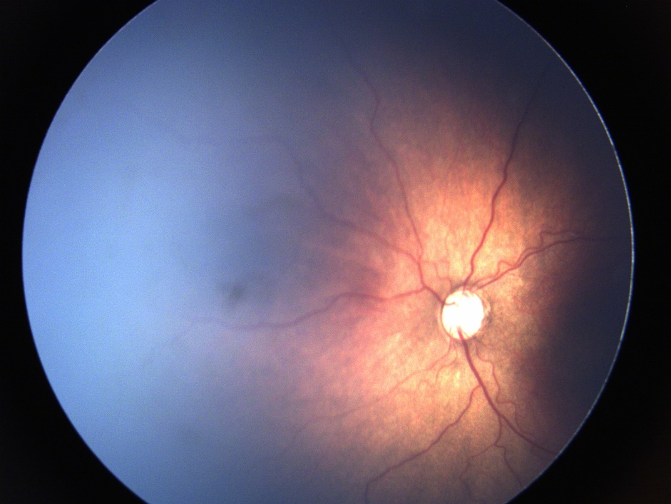 | 4 | 3 | 2 | 4
Pre-Plus Classified\61\' | CEFCF1ED-7DD9-45F2-A036-A762A5A703DE | 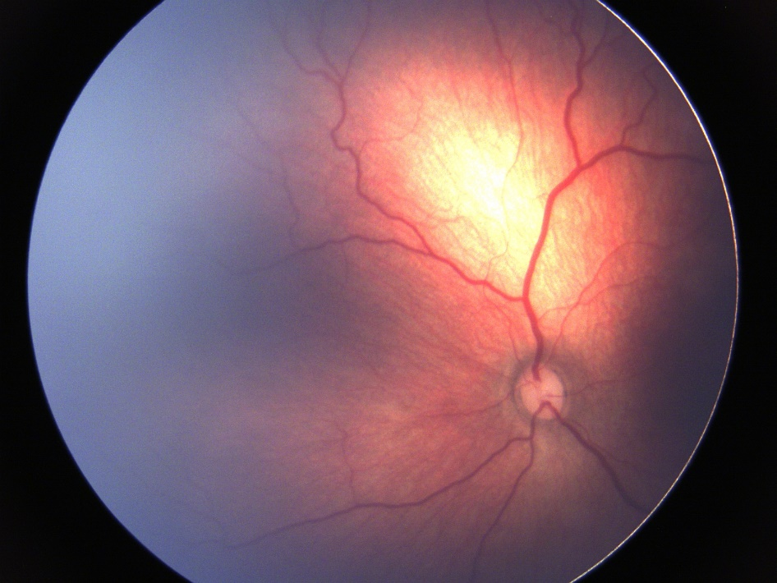 | 3 | 3 | 2 | 4
Pre-Plus Classified\59\' | D999A976-1541-4756-810F-4BE18FCE6854 | 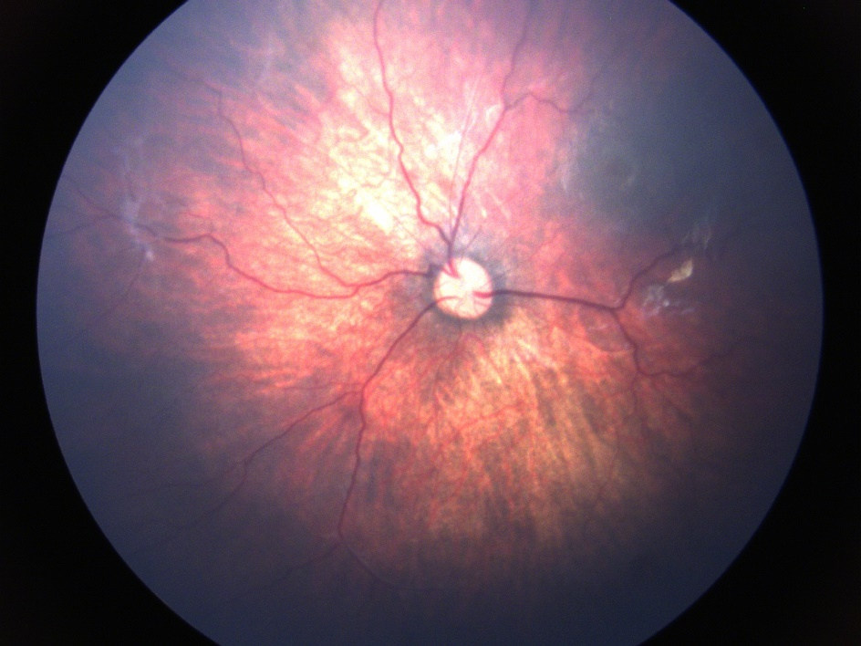 | 3 | 2 | 1 | 4
Pre-Plus Classified\34\' | DA3AEEF8-4770-4DAB-AA84-84D2F604C797 | 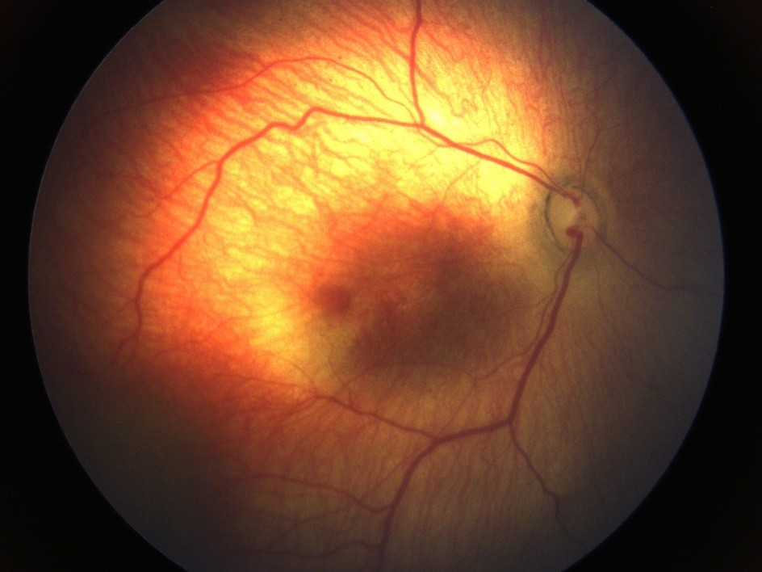 | 3 | 3 | 2 | 4
Plus-Classified\44\' | DB9B208F-5611-4628-8C82-2AD3DB556622 | 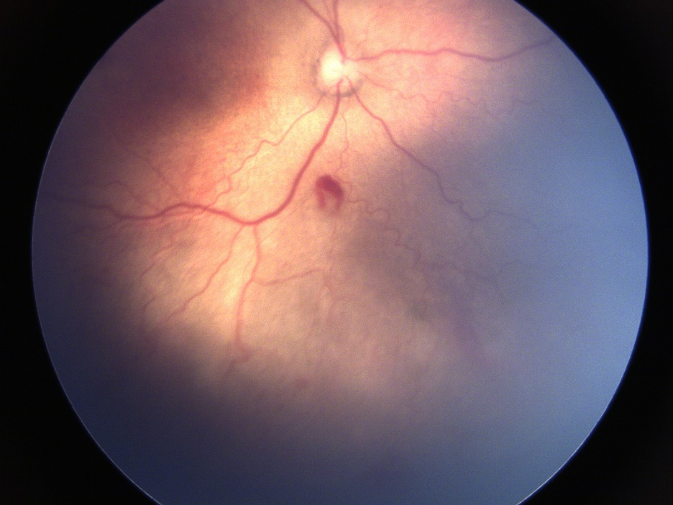 | 4 | 3 | 2 | 4
Pre-Plus Classified\102\' | DD7C7C9A-8926-4C40-9470-5C10BF3CC124 | 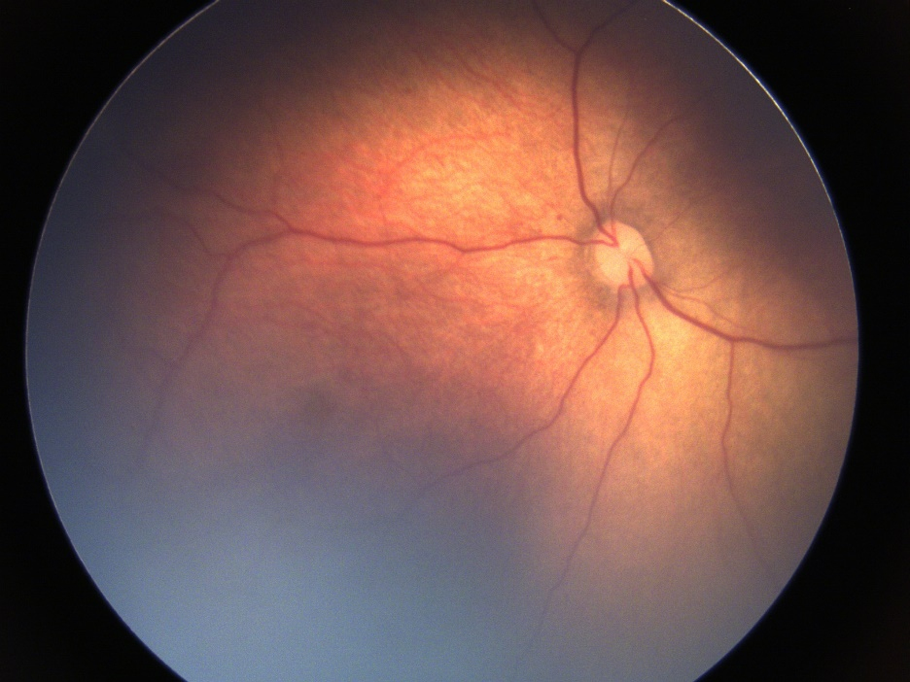 | 2 | 1 | 1 | 2
Plus-Classified\43\' | DEB579C1-77FB-44AD-9846-73F599EFA981 | 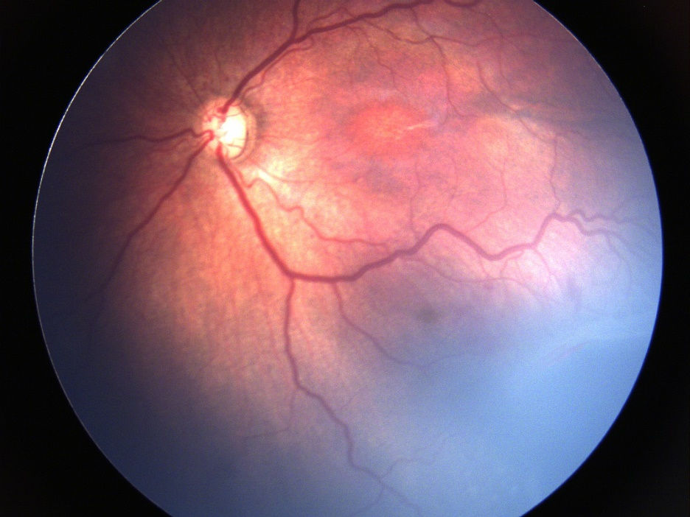 | 4 | 4 | 3 | 4
Pre-Plus Classified\106\' | E95B0B4A-16B5-49AE-BA6D-CD09EED9F58E | 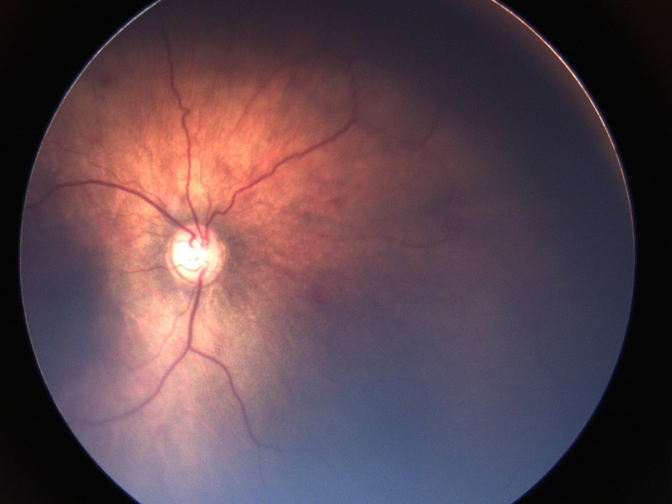 | 3 | 2 | 2 | 3
Pre-Plus Classified\66\' | EADE0750-5594-488C-B461-9538675C365F | 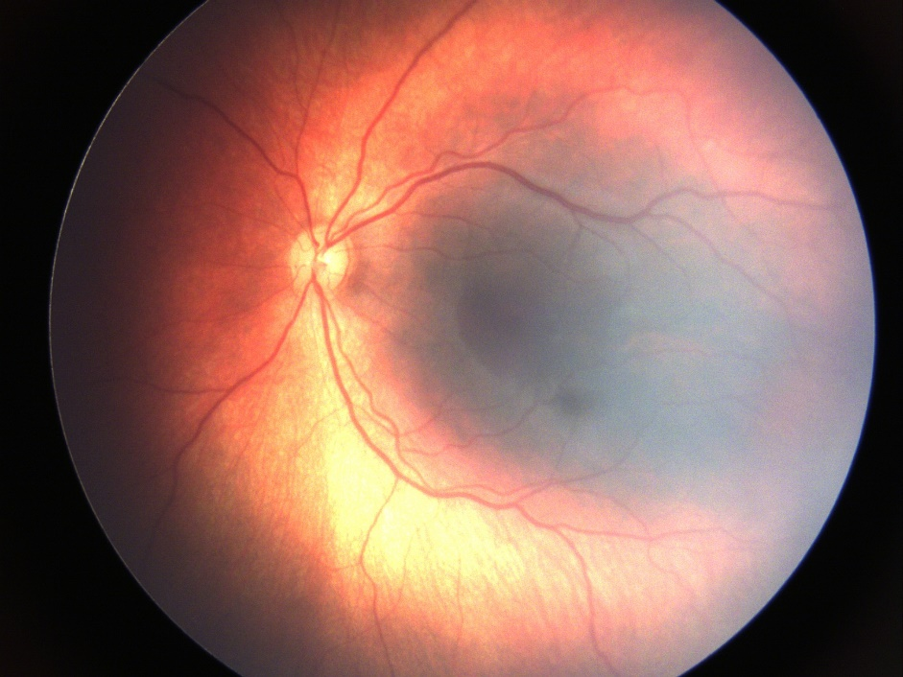 | 2 | 2 | 2 | 1
Pre-Plus Classified\40\' | EB90A4D9-14E2-4F78-BBB5-360C2E19C424 | 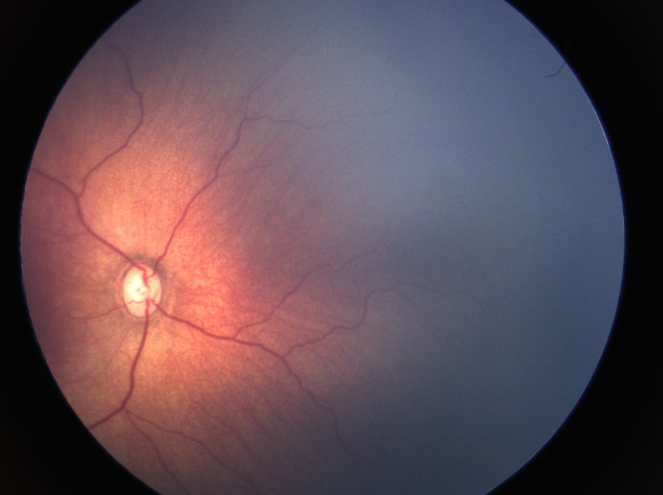 | 2 | 2 | 1 | 2
Pre-Plus Classified\53\' | F32679C5-F3BE-4729-86F7-6A724D8FCC61 | 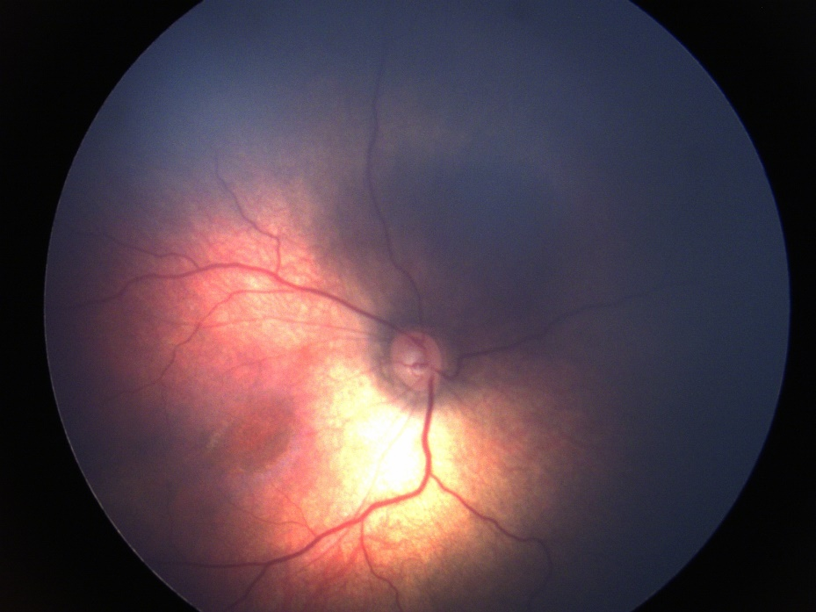 | 2 | 1 | 1 | 3
Pre-Plus Classified\45\' | F48FC24E-5D78-47BF-99DA-A0319618B258 | 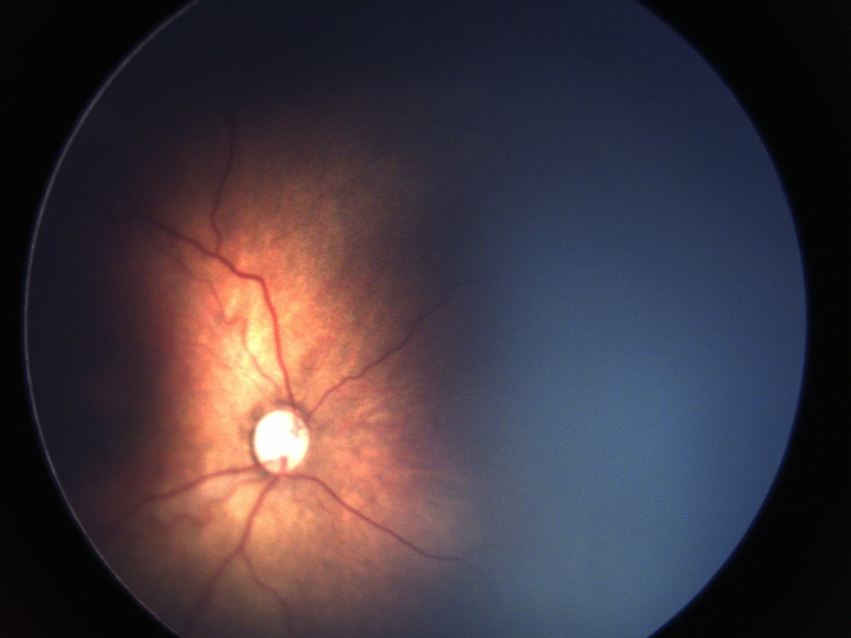 | 3 | 3 | 2 | 3
Pre-Plus Classified\15\' | F721BE17-A34C-4425-867F-899E8EAAFA45 | 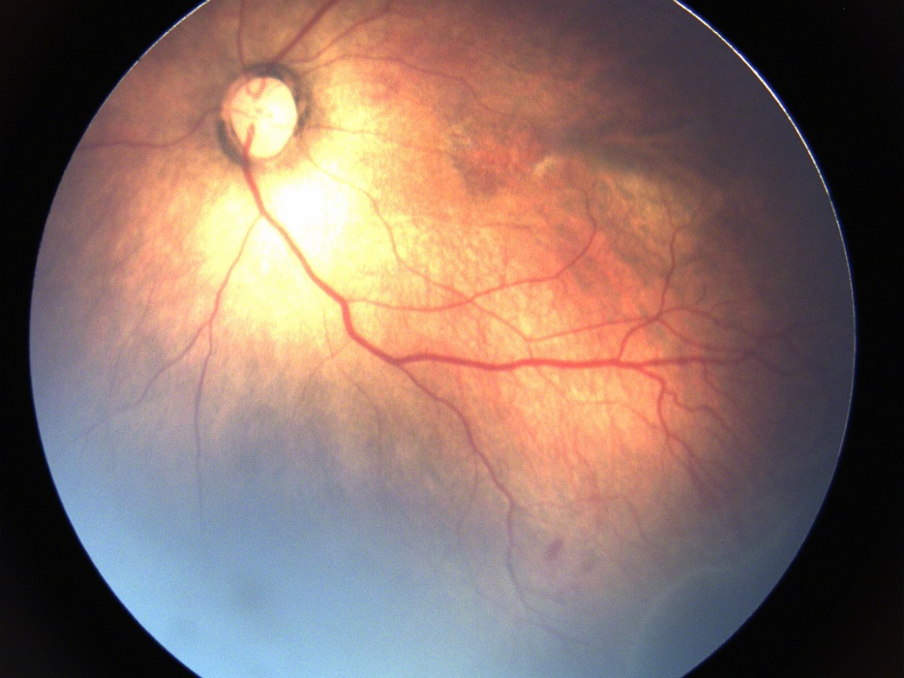 | 2 | 2 | 2 | 3
Plus-Classified\19\' | FFF7D19C-7D23-440B-9161-2E8B0790E1DF | 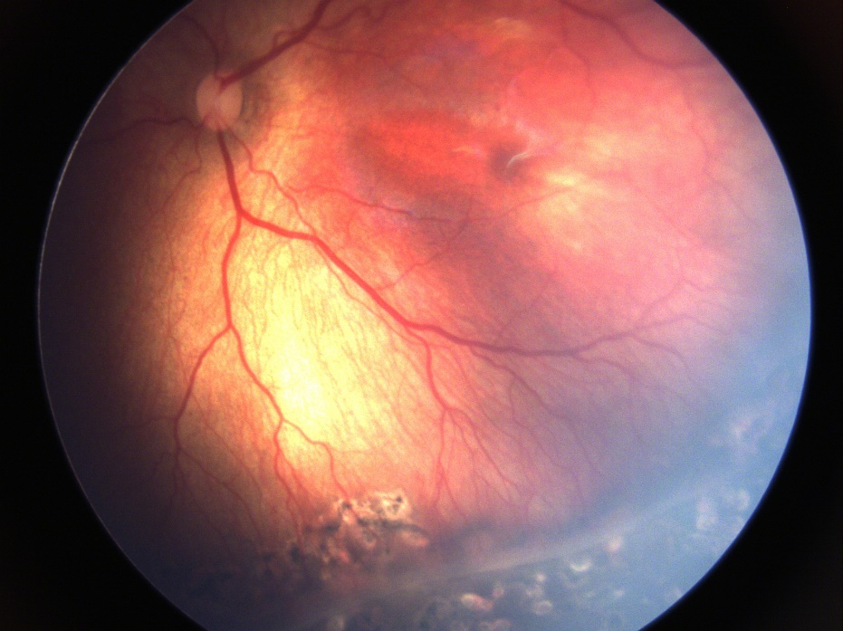 | 4 | 4 | 2 | 4

